COUNCIL ASSESSMENT REPORT
SYDNEY EASTERN CITY PLANNING PANEL
PANEL REFERENCE & DA NUMBER | PPSSEC-344 – S.4.55(2) - DA.2021.44
ORIGINAL PROPOSAL  PROPOSAL AS MODIFIED | Development Consent No.44/2021 was issued on 1 December, 2022 for “Demolition of the existing structures and the construction of a mixed use development known as ‘Burwood Place” comprising five (5) towers above a three storey podium with 1,041 residential units, 30,044 of non-residential gross floor area for retail, commercial, child care and entertainment/cinema uses, 6-7 levels of basement parking with 1,757 car parking spaces, and public domain areas”.  A Section 4.55(2) Application was lodged on 18 October 2024 which seeks to modify the abovementioned consent involving reconfiguration of residential and retail components, introduction of a hawker’s market, changes to landscaping, childcare centre use and public domain facilities. Extended operating hours are proposed to allow for 24 hours, 7 days a week trading for retail uses.
ADDRESS | Lot 1 DP 588368 (42-50 Railway Parade – Block 1)  Lot 16 DP 832440 (52-60 Railway Parade – Block 2)  Lot 1 DP 1135855 (Wynne Avenue – part of)  Lot 3 DP 588368 (Public road between Wynne Ave & Lot 1  DP 588368)
APPLICANT | Andrew Khoudeir
OWNER | Burwood Tower Holdings Pty Ltd  Burwood Council
DA LODGEMENT DATE | 18 October 2024
APPLICATION TYPE | S.4.55(2) Modification Application
REGIONALLY SIGNIFICANT CRITERIA | Section 2.19(1) and Clause 2 – General development over $30 million and Clause 3 – Council related development over $5 million of Schedule 6 of State Environmental Planning Policy (Planning Systems) 2021 declares the proposal regionally significant development because the CIV of the project is $602,019,803 and the development site includes part of a public road owned by Burwood Council.
CIV | $779,244,017.00
CLAUSE 4.6 REQUESTS | N/A
LIST OF ALL RELEVANT PLANNING CONTROLS (S4.15(1)(A) OF EP&A ACT) | - State Environmental Planning Policy (Biodiversity and  Conservation) 2021  - State Environmental Planning Policy (Sustainable  Buildings) 2021  - State Environmental Planning Policy (Housing) 2021 (which incorporates some of the provisions of State  Environmental Planning Policy No 65—Design Quality of Residential Apartment Development which has been repealed)  - State Environmental Planning Policy (Planning  Systems) 2021  - State Environmental Planning Policy (Resilience and  Hazards) 2021  - State Environmental Planning Policy (Transport and  Infrastructure) 2021  - Burwood Local Environmental Plan 2012  - Burwood Development Control Plan 2013
AGENCY RREFERRALS | WaterNSW, Sydney Trains and Transport for NSW
TOTAL & UNIQUE SUBMISSIONS & KEY & ISSUES IN SUBMISSIONS | Three (3) submissions containing objections to the proposed development.  - Public domain interface and design  - Wynne Avenue traffic/ road changes  - ADG Compliance  - Urban Design Review  - Loss of landscaping  - Loss of splash play/ water feature  - Traffic arrangements
DOCUMENTS SUBMITTED FOR CONSIDERATION | - Revised Architectural Plans  - Landscape Design Report  - ADG Compliance Plans  - RFI Cover Letter  - BCA Letter  - Hawkers Market retail strategy  - Mechanical Ventilation Statement  - Traffic Impact Statement  - Preliminary Lighting Strategy  - Preliminary lighting Plans  - Justification Plan  - Architectural Response – Council’s RFI’s  - Section 4.55 Response Letter – Landscape Architecture  - Burwood Place Section 4.55 RFI Responses
SPECIAL INFRASTRUCTURE CONTRIBUTIONS (S7.24) | N/A
RECOMMENDATION | Approval
DRAFT CONDITIONS TO APPLICANT | Yes
SCHEDULED MEETING DATE | 18 September 2025
PLAN VERSION
PREPARED BY | Julian Sciarrone (Executive Town Planner)
DATE OF REPORT | 4 September 2025

EXECUTIVE SUMMARY

The subject S.4.55 (2) Modification Application seeks consent for modifications to the approved Development Application (DA) DA.2021.44 relating to a mixed use development known as Burwood Place. Amendments include the reconfiguration of residential and retail components, the introduction of a hawker’s market, and changes to landscaping, childcare centre use and public domain facilities. Extended operating hours are proposed to allow for 24 hours, 7 days a week trading for retail uses.

The subject site is known as No. 42-60 Railway Parade, Burwood and includes the portion of Wynne Avenue located between the lots.

The site is located within the MU1 Mixed Use Zone pursuant to the Burwood Local Environmental Plan 2012. The development is characterised as a mixed-use development which is permitted in the zone. As such, the proposed modifications can be considered by the Panel.

The modified development involves the reconfiguration of areas which result in a reduction in the overall GFA. As such, additional GFA has been used to accommodate the proposed hawker’s market, basement retail spaces and the introduction of an extra level to ‘Tower C’. The proposed modifications do not result in any change to the approved height of the development holistically, yet propose minimal changes to GFA, FSR, landscaped areas and an increase in the number of carparking spaces. Refer to Table 1 for further details. Notwithstanding, the development remains compliant with the Burwood LEP 2012 height and FSR development standards.

The application was placed on public exhibition from 14 November 2024 until 30 December 2024. A total of three (3) submissions were received, all objecting to the development. The objections primarily related to an increase in noise and light pollution and an increase in traffic congestion resulting from the modifications. Concerns were also raised on the safety and management of a 24/7 trading economy proposed within the retail spaces of the development.
The application is referred to the Sydney Eastern City Planning Panel as the proposal is Council related development with a capital investment value of more than $30 million The updated CIV is $779,244,017.00.

The application was reviewed by the Burwood Design Review Panel on 17 December 2025, where key issues surrounding the design of the development were discussed. These issues included context and neighbourhood character, built form and scale, density, sustainability, landscaping and aesthetics.

A Request for Information letter was sent to the applicant on 20 December 2024 outlining these issues. In response, the applicant submitted updated plans and documents on 3 February 2025.

The application was considered again by the Burwood Design Review Panel on 20 May 2025, where similar issues regarding the design of the development were raised. These issues included context and neighbourhood character, built form and scale, density, sustainability, landscaping and aesthetics.

A second Request for Information was issued to the applicant on 11 June 2025, detailing the abovementioned design issues, along with concerns regarding the public domain of the proposal and traffic. Amended plans were submitted to Council on 3 July. The amended plans were assessed and all previous issues raised have been resolved subject to conditions of consent. Accordingly, the application is considered to be satisfactory and achieves aFn improved planning outcome.

Following a detailed assessment of the proposal, pursuant to Section 4.16(1)(b) of the EP&A Act, The S 4.55(2) modification application is recommended for approval subject to the reasons contained at Attachment A of this report.

1. THE SITE AND LOCALITY
  - The Site

The subject site is known as 42-60 Railway Parade, Burwood and consists of two (2) “blocks”. No.42-50 Railway Parade is known as ‘Block 1’ and No.52-60 Railway Parade is known as ‘Block 2’ for the purposes of this application (refer Figure 1). The overall site is bounded by Railway Parade to the north (frontage 211.985m), Clarendon Place to the east (frontage 74.5m), the Emerald Square development to the south (on the eastern side of Wynne Avenue – frontage 103.79m), Unity Place to the south (on the western side of Wynne Avenue – frontage 75.79m) and Burwood Library and a Council car park to the west (frontage 76.155m). The overall area of the subject site is 15,768.7m². The site is located on the south-western edge of Burwood Town Centre as defined by the Burwood Development Control Plan 2013 (BDCP 2013).

The site contains multiple lots, including the following:
Address | Lot/DP | Owner | Area (approx.)
42-50 and 52-60 Railway Parade, Burwood (Block 1 and Block 2) | Lot 1 DP 588368 and Lot 16 DP 832440 | Burwood Tower Holdings Pty Ltd | 14,363m²
Wynne Avenue (part) | Lot 1 DP1135855 and an allotment with no legal description | Burwood Council | 1,405.7 m²
Total |  |  | 15,768.7m²

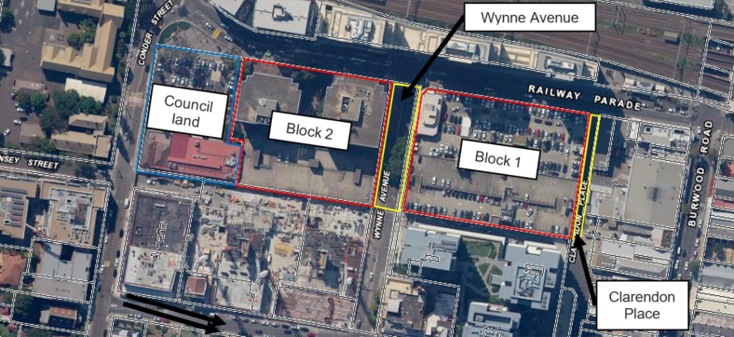
Figure 1 – Aerial image of the subject site and immediate locality.
Source: (Statement of Environmental Effects prepared by Gyde Consulting 24 June, 2022)

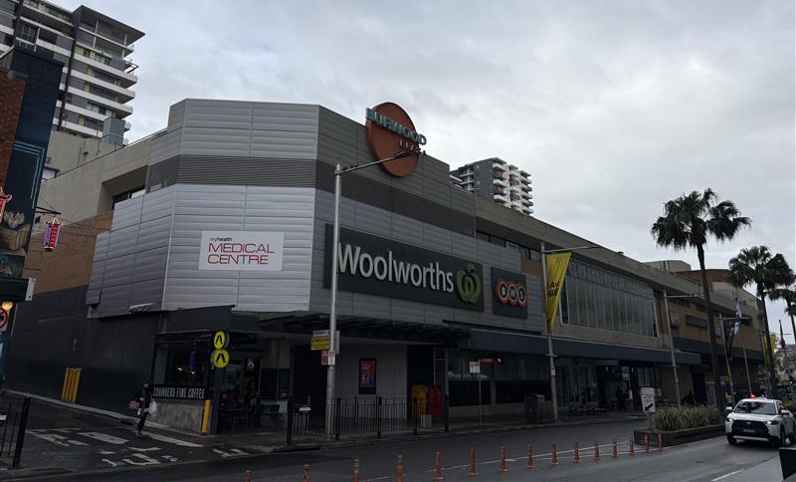
Figure 2 – Image of Burwood Place ‘Block 1’ (currently Burwood Plaza).
Source: (Council staff July 2025)
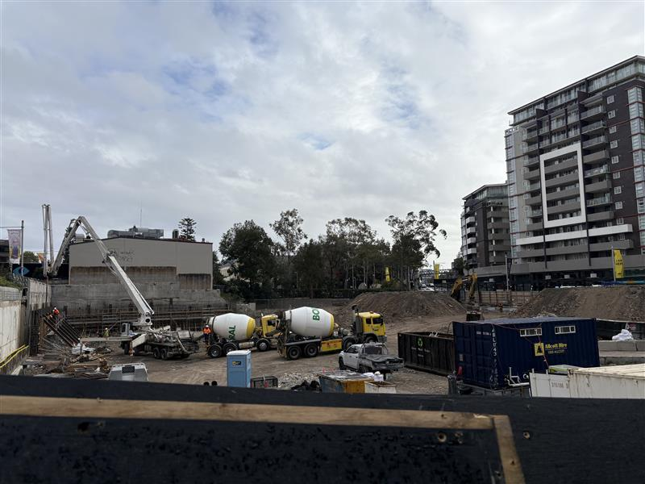
Figure 3 – Image of Burwood Place ‘Block 2’ (currently under demolition and excavation).
Source: (Council staff July 2025)
  - The Locality

The site is generally flat but gently rises towards the south. 52-60 Railway Parade (Block 2) previously comprised 2 x 8 storey commercial office buildings as well as a 4-storey car park which has now been demolished., whilst 42-50 Railway Parade (Block 1) currently accommodates the Burwood Plaza Shopping Centre, a 2-storey building with rooftop carpark. A total of eleven (11) trees line the pedestrian walkway on Wynne Avenue, which is a two-way vehicular thoroughfare providing access to both sites. Clarendon Place is a two-way (dead end) street providing service access to properties fronting Burwood Road and Belmore Street. An existing through-site link connects Burwood Plaza, across Clarendon Place through the Burwood Chinatown Mall to Burwood Road to the east.

The subject site is surrounded by the following development:

- North: Railway Parade, Burwood Train Station and ‘1 Railway Parade’, an existing mixed-use development up to 20 storeys. On the northern side of the railway line is Burwood Park, Westfield Shopping Centre, Parramatta Road and the future location of the Burwood North Metro Station.
- East: Burwood Chinatown and Clarendon Place adjoins the site to the east. East of Chinatown are low-rise commercial developments fronting Burwood Road, including Burwood Hotel. This site has a DA approval for ‘Burwood Central’, a multi storey mixed-use development, whose consent has not yet been acted upon.
- South: Emerald Square, Unity Place and Burwood Grand, which consists of three mixed-use towers ranging from 11 to 19 storeys in height.
- West: 2-4 Conder Street carpark (DA.2022.44) and Burwood Public School, a two-storey heritage listed building. Burwood Council Chambers are located west of the site.

The parcel adjoining the subject site to the west, known as No’s 2-4 Conder street, Burwood is denoted as “Council Land” and does not form part of this application, but is the subject of a separate approval for an urban park and cultural centre (Development Consent No. 2022/44). However, there are a number of conditions contained within Development Consent No. 2022.44 requiring vehicular access to the basement carpark underneath the Urban Park and Cultural Centre to be obtained via Basement Level 1 of the Burwood Place development.

Photographs of the surrounding development are provided in Figures 4 through 9.

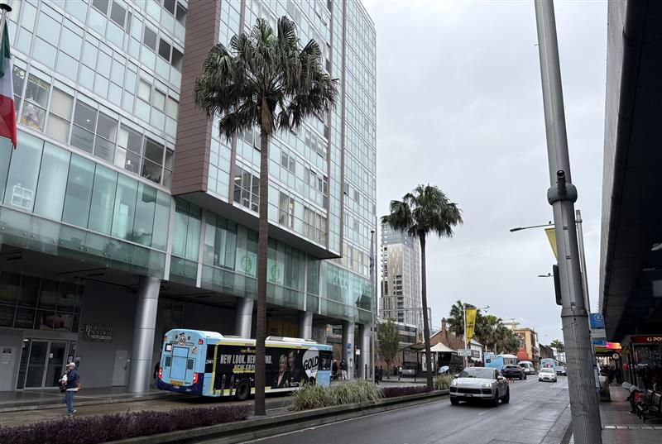
Figure 4 – 1 Railway Parade facing towards Burwood Station.
Source: (Council staff July 2025)

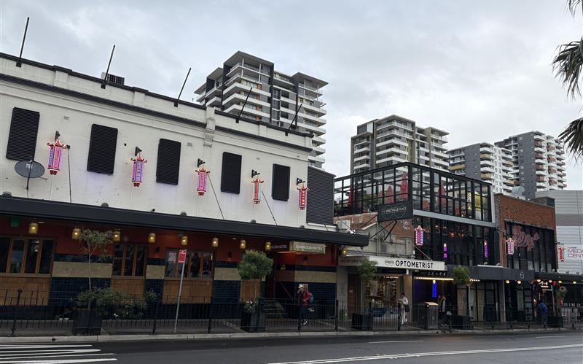
Figure 5 – Burwood Hotel (left), Burwood Chinatown (middle) and Burwood Plaza (right) as taken from Railway Parade. Burwood Grand and Unity Place are located behind.
Source: (Council staff July 2025)
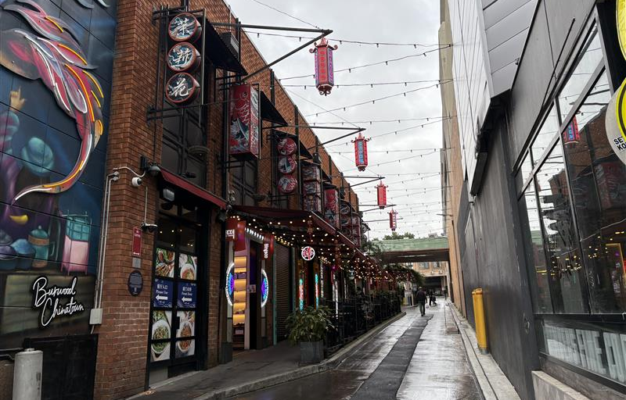
Figure 6 – Clarendon Place located between Burwood Chinatown and ‘Block 1’ (currently Burwood Plaza).
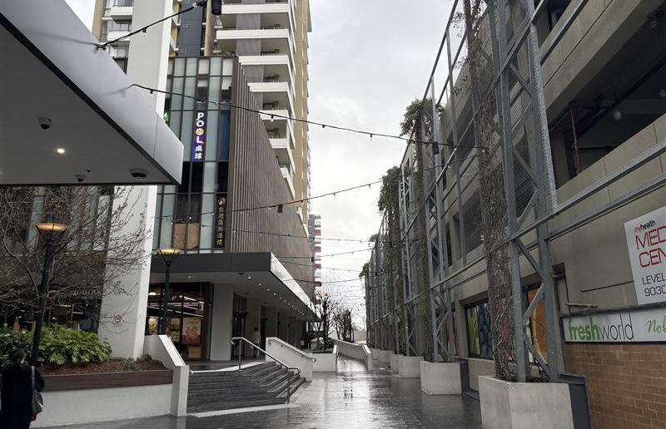
Source: (Council staff July 2025)
Figure 7 – Walkway between Emerald Square and ‘Block 1’ (currently Burwood Plaza).
Source: (Council staff July 2025)
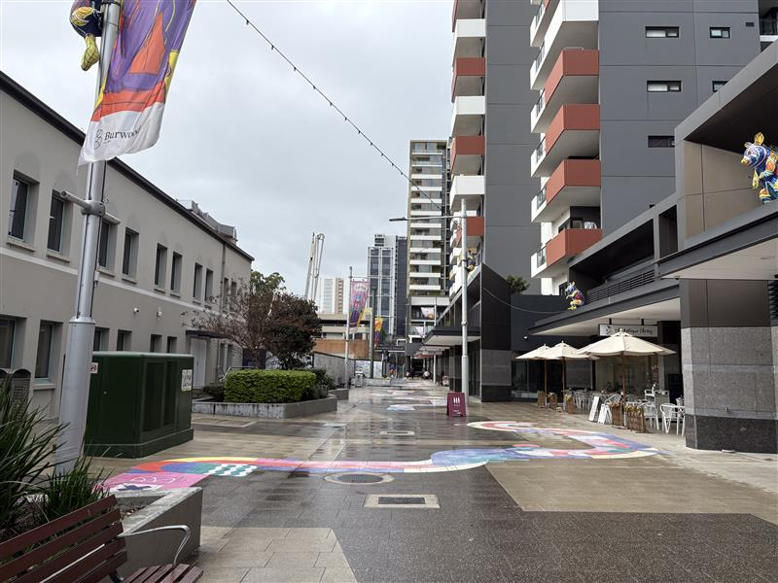
Figure 8 – Unity Place with Burwood Council Chambers (left) and Burwood Grand (right) and ‘Block 2’ (under demolition) and Emerald Square ahead.
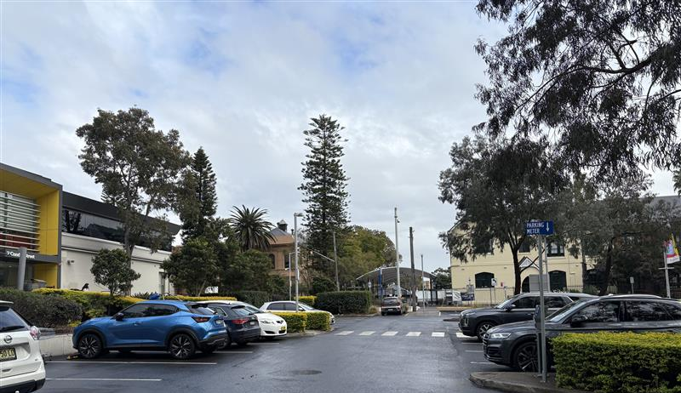
Source: (Council staff July 2025)
Figure 9 – Burwood Council carpark and Burwood Public School.
Source: (Council staff July 2025)
2. THE PROPOSAL AND BACKGROUND

2.1 The Proposal

The proposal seeks consent for modifications to the approved Burwood Place development. Burwood Place was approved under Development Consent No. 44/2021. The consent was issued on 1 December 2022 for “demolition of the existing structures and the construction of a mixed use development known as ‘Burwood Place” comprising five (5) towers above a three storey podium with 1,041 residential units, 30,044 metres of non-residential gross floor area for retail, commercial, childcare and entertainment/cinema uses, 6-7 levels of basement parking with 1,757 car parking spaces, and public domain areas”. The southern elevation of the approved project is shown in Figure 10 below depicting five (5) towers which form part of the development. Specifically, Tower A comprises 41 levels, Tower B comprises 21 levels, Tower C comprises 39 levels, Tower D comprises 32 levels and Tower E comprises 10 levels.

It is noted that demolition works have commenced on the office buildings situated on “Block 2” of the development known as No.52-60 Railway Parade, Burwood.

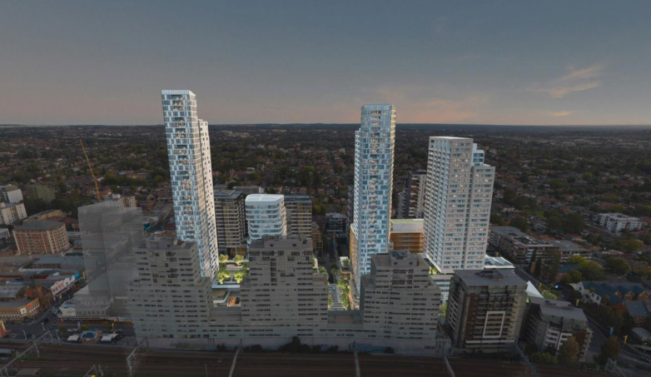
Figure 10 – Approved development as shown from southern elevation (original DA.2021.44)
Source: (Statement of Environmental Effects prepared by Gyde Consulting 24 June, 2022)

The current Section 4.55(2) application proposes to modify the abovementioned consent, with modifications including the reconfiguration of residential and retail components, introduction of a hawker’s market, changes to landscaping, childcare centre use and public domain facilities. Extended operating hours are proposed to allow for 24 hours, 7 days a week trading for retail uses.

The modification application proposes amendments to the residential, retail, commercial and public domain components of the approved development. The proposal as modified seeks redesign of the building’s structural elements, whilst including additional retail and residential spaces without exceeding the permissible height or FSR controls.

In addition to the changes above, the proposal seeks modifications to improve the public domain and landscaped areas. However, given the absence of information provided, this will not form part of the modification application as the submitted landscape plans are at a concept level only.

The key development data for both the approved development and the current Section 4.55 Modification Application is shown in Table 1 below.
Table 1: Key Development Data

Control | Approved Development | Proposed Development
Max Height | Lot 1 DP 588368 (Block 1) – 144m  Lot 16 DP 832440 (Block 2) – 136m | Lot 1 DP 588368 (Block 1) – 144m  Lot 16 DP 832440 (Block 2) – 136m  Note: height of Tower B has increased by 2.1 m, however, is still below the max 144m height limit of Block 1. This is achieved by increasing the height within the BHP but not the maximum height.
Max RL | RL 163.5m | RL 163.5m
GFA (Block 1 and 2)  GFA (Wynne Avenue) | Non-residential GFA – 48,173m²  Residential GFA – 102,839m²  Total – 151,022m²  1,165m² | Non-residential GFA – 43,203m²  Residential GFA – 102, 832m²  Total – 146,035m²  1,309m²
FSR | 10.51:1 (combined over both Lot 1 DP 588368 and Lot 16 DP 832440)  0.93:1 – Wynne Avenue | 10.17:1 (combined over both Lot 1 DP 588368 and Lot 16 DP 832440)  1:1 – Wynne Avenue
Landscaped Area | 4,913m² | 4,620 m²
No. Apartments | 1,041 | 1,041
No. Car Parking Spaces | 1,757 | 1,805

Structural Modifications

The following structural amendments are proposed:

- Eliminate transfer levels at the base of each tower and relying on localised transfers. (Refer to Figure 11 below)
- Continuous cores carried through from towers to basement in conjunction with review of tower lateral stability. (Refer to Figure 12 below).

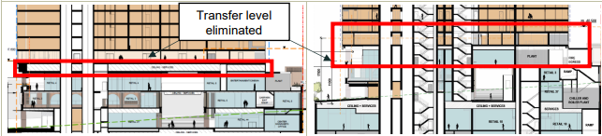
Figure 11 – Extract of the applicants submitted Section Plans
Source: (Studio.SC)

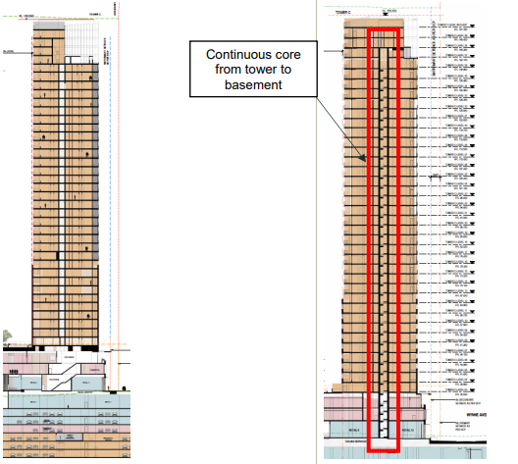
Figure 12 – Extract of the applicants submitted Section Plans
Source: (Studio.SC)
Services Modifications

The following service amendments have been implemented:

- Redistribution and developed design of substations. (Refer to Figure 13 and Figure 14 below).

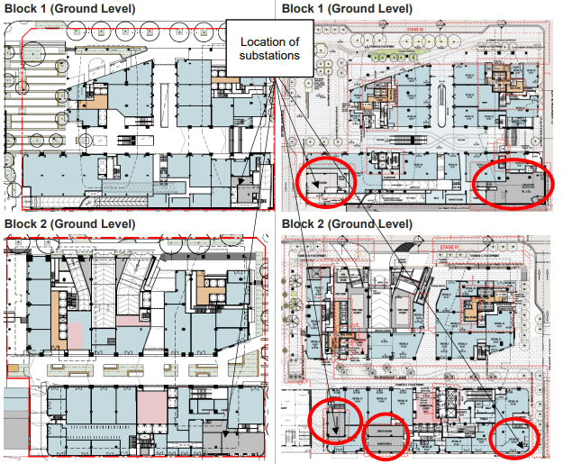
Figure 13 – Extract of the locations of the substations.
Source: (Statement of Environmental Effects prepared by Gyde Consulting 27 March 2025)

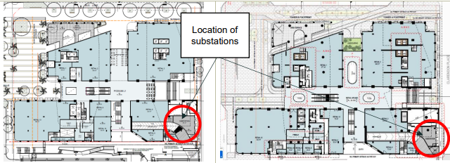
Figure 14 – Extract of the locations of the substations.
Source: (Statement of Environmental Effects prepared by Gyde Consulting 27 March 2025)
- The condenser plant rooms have been removed or reduced, with condensers now located on individual balconies, as shown below. This arrangement is consistent with Condition 70 of the original consent, which permits external plant such as air conditioning units, provided they are not visible from a public road, adjoining property, or public place.

Tower A

- Removal of the southern condenser plant room is proposed which has allowed for an updated three (3) bedroom layout across Levels 4-34.

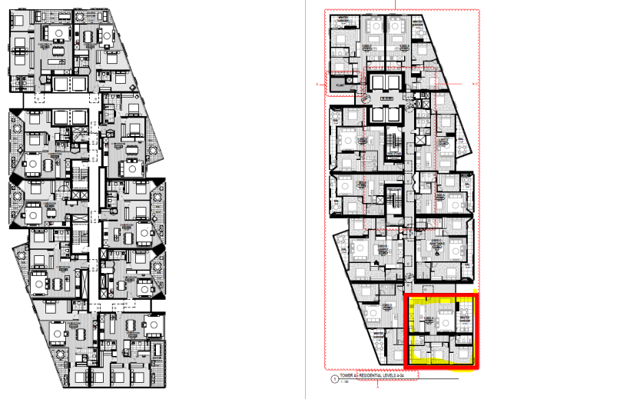
Figure 15 – Extract of applicants submitted Tower A Level 4-34 floor plan.
Source: (Statement of Environmental Effects prepared by Gyde Consulting 27 March 2025)

Tower B

- Both condenser rooms are proposed to be removed, with changes reflected in these locations throughout the full height of the tower.

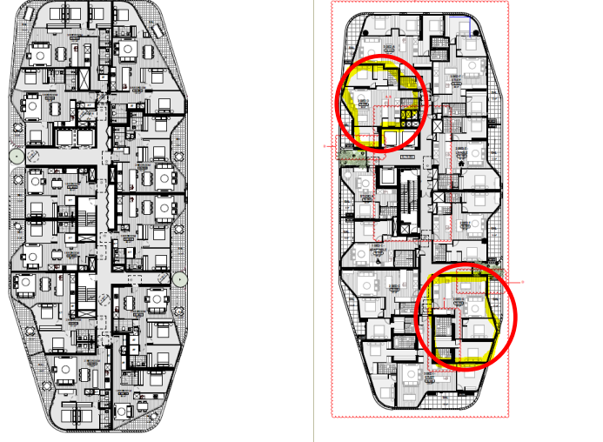
Figure 16 – Extract of applicants submitted Tower B floor plan.
Source: (Statement of Environmental Effects prepared by Gyde Consulting 27 March 2025)

Tower C

- Following the removal of the southern condenser plant and updates to adjacent apartments, a one-bedroom unit is proposed to be converted into a unit with one bedroom and a study. Apartments in this location have been revised all the way up the tower.

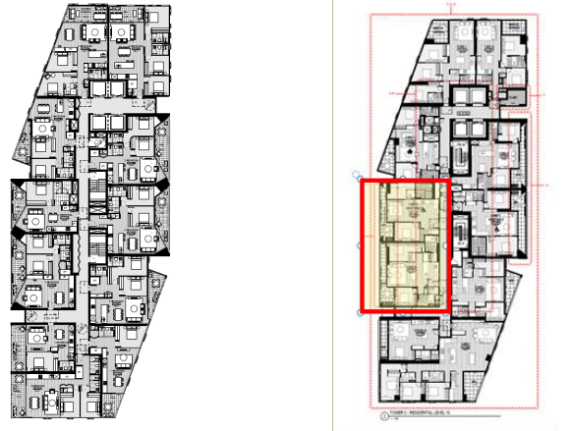
Figure 17 – Extract of applicants submitted Tower C floor plan.
Source: (Statement of Environmental Effects prepared by Gyde Consulting 27 March 2025)

Tower D

- The condenser room is proposed to be reduced in size, allowing one of the previously undersized apartments to be enlarged.

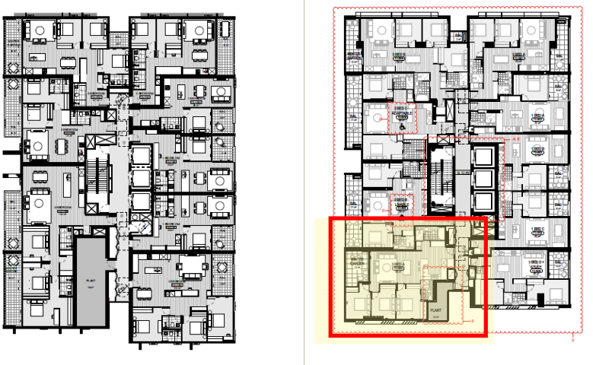
Figure 18 – Extract of applicants submitted Tower D floor plan.
Source: (Statement of Environmental Effects prepared by Gyde Consulting 27 March 2025)

Heat Pump Plant Rooms

- A heat pump plant room has been added to the terrace areas on the upper levels—primarily on Tower A, Level 38, and Tower C, Level 33—while Towers B and D have more discreetly located plant rooms.

Tower A

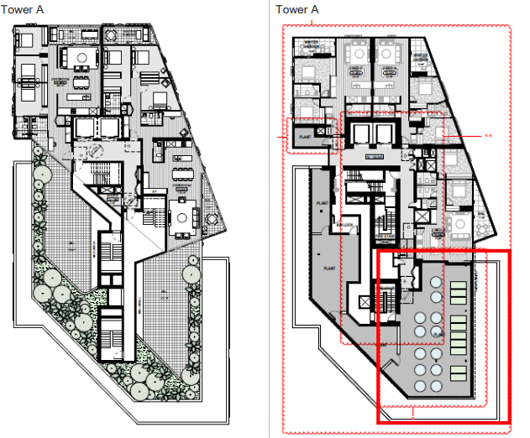
Figure 19 – Extract of applicants submitted Tower A Level 38 floor plan.
Source: (Statement of Environmental Effects prepared by Gyde Consulting 27 March 2025)

Tower B

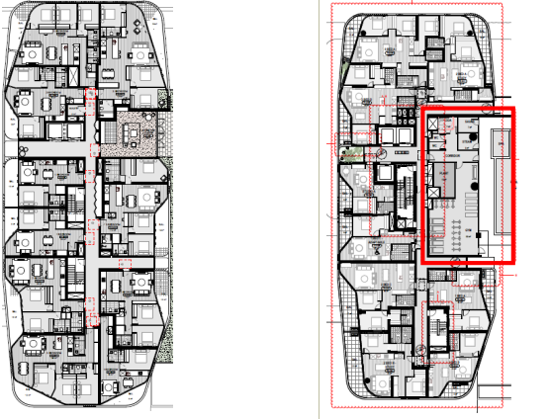
Figure 20 – Extract of applicants submitted Tower B floor plan.
Source: (Statement of Environmental Effects prepared by Gyde Consulting 27 March 2025)

Tower C

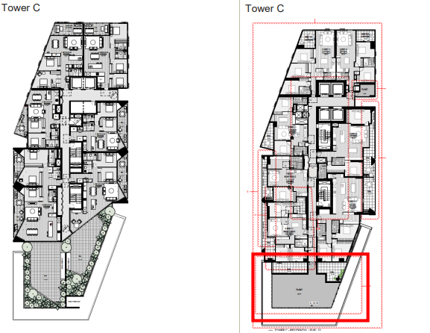
Figure 20 – Extract of applicants submitted Tower C floor plan.
Source: (Statement of Environmental Effects prepared by Gyde Consulting 27 March 2025)

Tower D

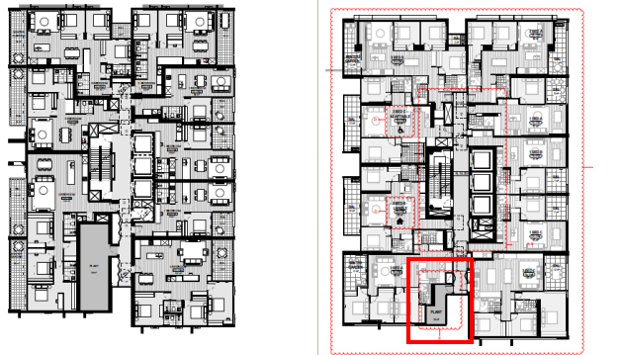
Figure 21 – Extract of applicants submitted Tower D floor plan.
Source: (Statement of Environmental Effects prepared by Gyde Consulting 27 March 2025

Apartment Consistency Changes

Tower A

- In Tower A, apartments are proposed to be included on level 3.

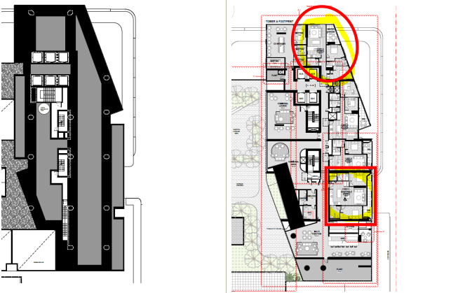
Figure 22 – Extract of applicants submitted Tower A, Level 3 floor plan.
Source: (Statement of Environmental Effects prepared by Gyde Consulting 27 March 2025

Tower B

- In Tower B, the studio apartments on Level 19 and Levels 20 are proposed to be combined with the adjacent two bedroom and one bedroom units to create larger apartments.

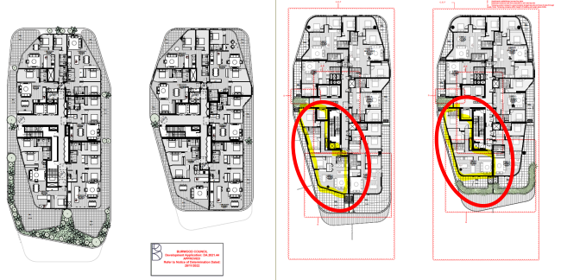
Figure 23 – Extract of applicants submitted Tower B, Levels 19 and 20 floor plan.
Source: (Statement of Environmental Effects prepared by Gyde Consulting 27 March 2025

Tower D

- One-bedroom apartments are proposed to be relocated to Level 23.

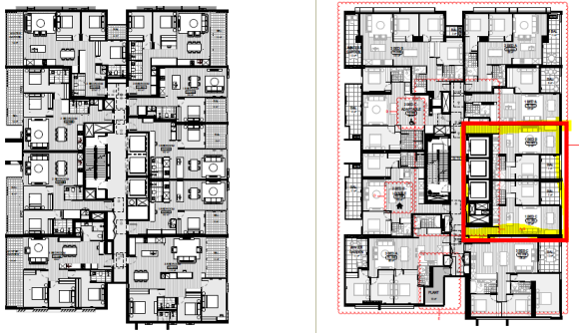
Figure 24 – Extract of applicants submitted Tower D Level 23 floor plan.
Source: (Statement of Environmental Effects prepared by Gyde Consulting 27 March 2025
Gross Floor Area

The proposal seeks to undertake numerous design modifications that result in a reduction of GFA. This includes the following:

- Reduction in residential lobby in basement areas.
- Service areas that were previously included as GFA.
- Optimisation of retail spaces.
- Balcony and terrace areas that are measured as GFA with outer walls less than 1.4m high.

The revised GFA calculation has allowed for additional GFA to be made available. The additional GFA available for each respective tower is as follows:

- Tower A – 2,020m²
- Tower B – 380m²
- Tower C – 1,220m²
- Tower D – 480m².

Subsequently, as a result of the design developments, the overall GFA available for redistribution equates to the following:

- 4,100m² of residential GFA from modification to the tower.
- 1,600m² of GFA from modifications to the basement.
- 4,560m² of GFA from modification to terraces and courtyard areas.

As such, the modifications to design development have resulted in 10,260m² of additional GFA. As such, the additional GFA is now proposed to accommodate the following:

- Hawkers Market.
- Other basement retail including an Asian grocer and large format specialised retail.
- Increase to the façade lines outwards to increase retail offerings.
- Express escalators.
- Amenities relocated from levels 4, 6 and 7 (of Block 2) to Level 3, 6 and 7.
- Introduction of a new level to Tower C.

Description of Changes

It is to be noted that the terraced area were previously counted towards gross floor area (GFA). These areas have now been altered in external wall detail to be in line with the definition of GFA, and are subsequently excluded from the GFA calculation. This is limited to the Tower D and Tower E podium levels only.

Tower D Podium

- The proposed revised detail includes a 1.35 metre solid glazed wall along the terrace of the childcare centre, which is below the 1.4 metres in height. Therefore, this terrace area is now excluded from the GFA calculation as part of this modification application.

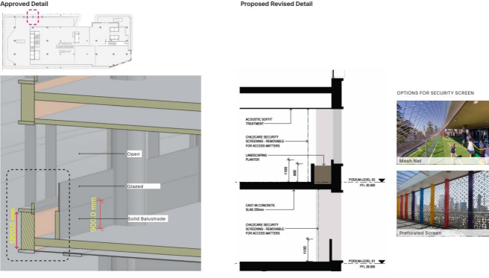
Figure 25 – Extract of applicants submitted revised 1.35m solid wall/glazing along the terrace of the childcare centre.
Source: (Statement of Environmental Effects prepared by Gyde Consulting 27 March 2025

Tower E Podium

- The proposed revised detail includes a 1.35 metre solid glazed wall along the terrace, which is below the 1.4 metres in height. Therefore, this terrace area is now excluded from the GFA calculation as part of this modification application.

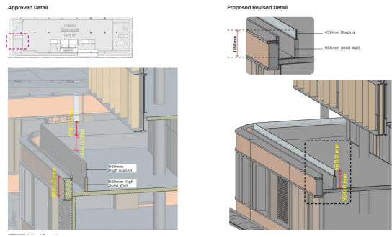
Figure 26 – Extract of applicants submitted revised 1.35m solid wall/glazing along the Tower E Podium.
Source: (Statement of Environmental Effects prepared by Gyde Consulting 27 March 2025

Tower B (Residential Level 18)

- The proposed revised detail includes a 1.35 metre solid wall/glazing along the terrace, which is below the 1.4 metres identified in the GFA definition. Therefore, this terrace area is now excluded from the GFA calculation in respect of this modification application.

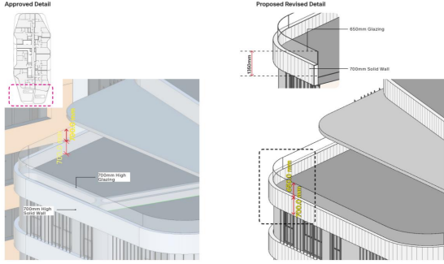
Figure 27 – Extract of applicants submitted revised 1.35m solid wall/glazing along the Tower B Level 18 terrace area.
Source: (Statement of Environmental Effects prepared by Gyde Consulting 27 March 2025

Tower C (Residential Level 37)

- A 2m solid wall/glazing is now proposed which is above the 1.4m identified in the GFA calculation. Therefore, this terrace areas has now been included into the GFA calculation.

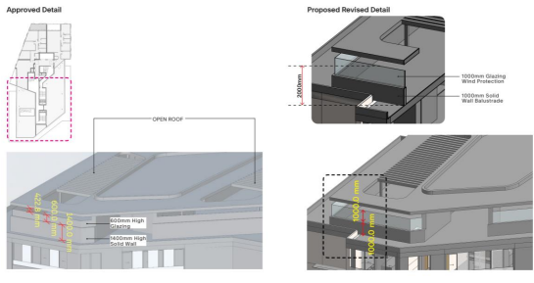
Figure 28 – Extract of applicants submitted revised 2m solid wall/glazing along the Tower C Level 37 terrace area.
Source: (Statement of Environmental Effects prepared by Gyde Consulting 27 March 2025

Tower D (Additional Level of Residential)

- An additional level of residential has been added to Tower D, due to elimination of the transfer level and relocation of pool to the Level 3 podium.

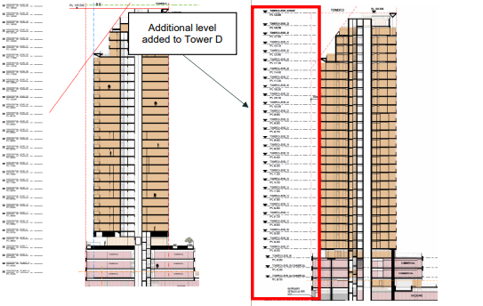
Figure 29 – Extract of applicants submitted section plans indicating the additional residential level to Tower D.
Source: (Statement of Environmental Effects prepared by Gyde Consulting 27 March 2025

Additional Retail Level

- An additional retail level added at Basement 2, with a void over at Basement 1.

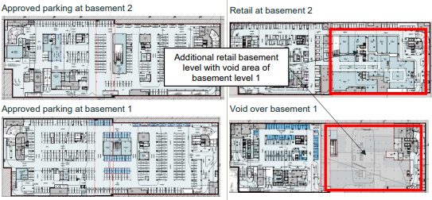
Figure 29 – Extract of applicants submitted Basement 1 and Basement 2 Plans.
Source: (Statement of Environmental Effects prepared by Gyde Consulting 27 March 2025

Proposed Residential Modifications

Tower A

- The floor to floor ceiling heights for each level within Tower A have been altered to allow for additional height in transitional floors and the penthouse levels.

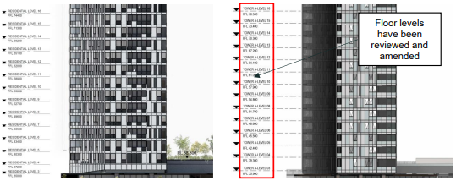
Figure 30 – Extract of applicants submitted Elevation Plans indicating the change to floor levels.
Source: (Statement of Environmental Effects prepared by Gyde Consulting 27 March 2025
Tower D

- Condenser louvers are proposed to be included along the elevation of Tower D.

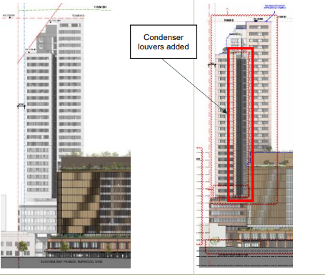
Figure 31 – Extract of applicants submitted Tower D Elevation Plan.
Source: (Statement of Environmental Effects prepared by Gyde Consulting 27 March 2025

Internal Apartment Modifications

- Introduction of island bench where possible in select residential apartments.

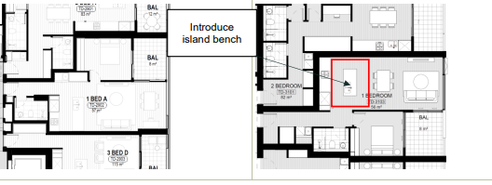
Figure 32 – Extract of applicants submitted Floor Plan.
Source: (Statement of Environmental Effects prepared by Gyde Consulting 27 March 2025

- Study nooks have been introduced in residential apartments, that double up as storage where possible.

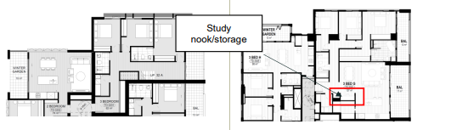
Figure 33 – Extract of applicants submitted floor Plan.
Source: (Statement of Environmental Effects prepared by Gyde Consulting 27 March 2025

- Bathtubs have been introduced to all 3-bedroom apartments.

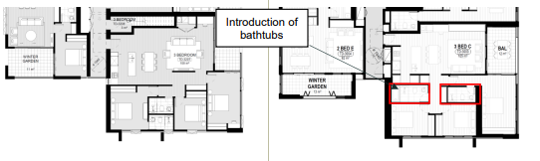
Figure 34 – Extract of applicants submitted 3 bedroom apartment floor plan.
Source: (Statement of Environmental Effects prepared by Gyde Consulting 27 March 2025
- Introduction of common areas to the upper levels of Towers A and C.

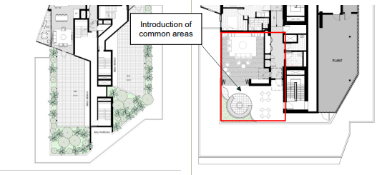
Figure 35 – Extract of applicants submitted upper levels to Towers A and C.
Source: (Statement of Environmental Effects prepared by Gyde Consulting 27 March 2025

- Relocation of the swimming pool from level 6 in Tower D, to level 3. This has been done to improve accessibility from both towers, without the need to come to the ground floor.

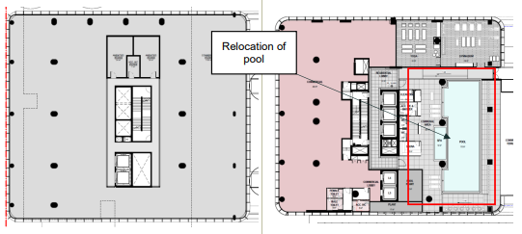
Figure 36 – Extract of applicants submitted Tower D Level 3 floor plan.
Source: (Statement of Environmental Effects prepared by Gyde Consulting 27 March 2025

- Relocation of the swimming pool from Tower A to Tower B podium. This modification is a result of columns being relocated and removing the need for large transfers.

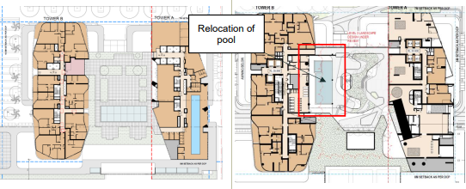
Figure 37 – Extract of applicants submitted Tower B podium.
Source: (Statement of Environmental Effects prepared by Gyde Consulting 27 March 2025

- The apartment mix has been updated as part of this modification application, however, there are still 1,041 units, consistent with the original approval. Below is a breakdown of the changes to the apartment mix for each building.

Original Approval | Current S.4.55(2) Modification
Tower A  Studio: 90  1 Bedroom: 80  2 Bedrooms: 197  3 Bedrooms: 36  Total: 346 | Tower A  Studio: 0  1 Bedroom: 68  2 Bedrooms: 241  3 Bedrooms: 36  Total: 345
Tower B  Studio:0  1 Bedroom: 43  2 Bedrooms: 94  3 Bedrooms: 37  4 Bedrooms: 2  Total: 176 | Tower B  Studio: 18  1 Bedroom: 35  2 Bedrooms: 72  3 Bedrooms: 52  4 Bedrooms: 0  Total: 177
Tower C  Studio: 8  1 Bedroom: 72  1 Bedroom + Study: 2  2 Bedrooms: 187  3 Bedrooms: 39  4 Bedrooms: 1  Total: 309 | Tower C  Studio: 10  1 Bedroom: 37  1 Bedroom + Study: 0  2 Bedrooms: 199  3 Bedrooms: 61  4 Bedrooms: 0  Total: 307
Tower D  Studio: 0  1 Bedroom: 69  2 Bedrooms: 75  3 Bedrooms: 66  4 Bedrooms: 0  Total: 210 | Tower D  Studio: 0  1 Bedroom: 61  2 Bedrooms: 70  3 Bedrooms: 81  4 Bedrooms: 0  Total: 212
Total Overall Apartments: 1,041 | Total Overall Apartments: 1,041

- Re-planning of upper levels to accommodate a necessary plant room ensuring alignment with the solar and height plane.

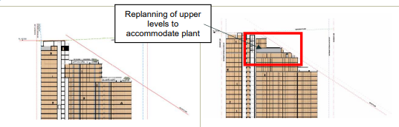
Figure 38 – Extract of applicants submitted section plan.
Source: (Statement of Environmental Effects prepared by Gyde Consulting 27 March 2025

- Façade rationalisation – to improve amenity and create more functional internal spaces by removing the angled façade.

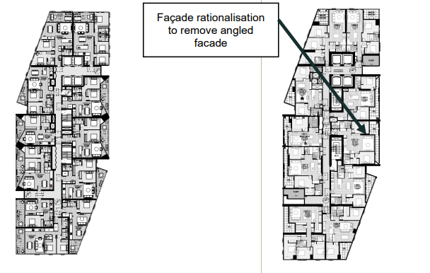
Figure 39 – Extract of applicants submitted Tower C floor plan.
Source: (Statement of Environmental Effects prepared by Gyde Consulting 27 March 2025

Retail Modifications

- Introduction of a Hawkers Market and Car Street to B2. An express escalator has been introduced from the ground floor down to this level. The layout has also been amended to allow for improved back of house access and servicing to predominate retailers, greater efficiency in circulation and vertical transportation. Services have been relocated above ramp areas to maximise height, and a direct access escalator has been provided to Basement 2 to Hawkers Market.
- The proposed operating hours of the Hawkers Market and Car Street is 24/7. It is also proposed to amend the operating hours of the existing approved basement retail to also be operating 24/7. This is only proposed to the operation of the retail premises and does not include the operating hours of the loading dock.

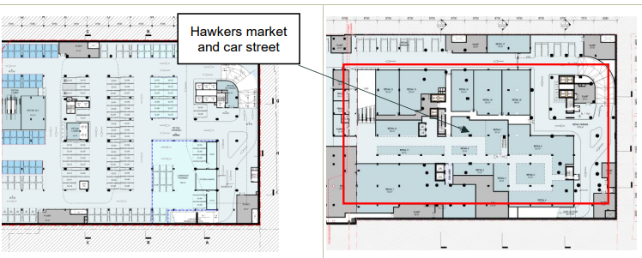
Figure 40 – Extract of applicants submitted modified B2 Plan which now includes the Hawkers Market.
Source: (Statement of Environmental Effects prepared by Gyde Consulting 27 March 2025

- Proposed retail level has a void cut out of Basement Level 1 to achieve a 6m floor to floor.

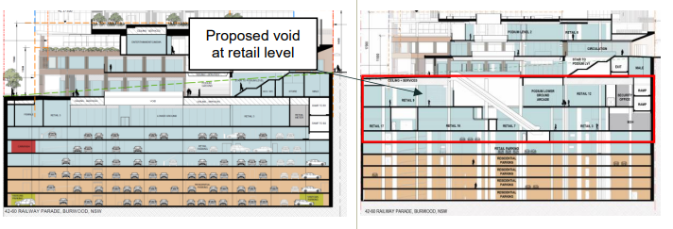
Figure 41 – Extract of applicants submitted modified Section Plan indicating the new void at the retail level.
Source: (Statement of Environmental Effects prepared by Gyde Consulting 27 March 2025

- An additional basement level proposed to accommodate the Hawkers Market and Car Street.

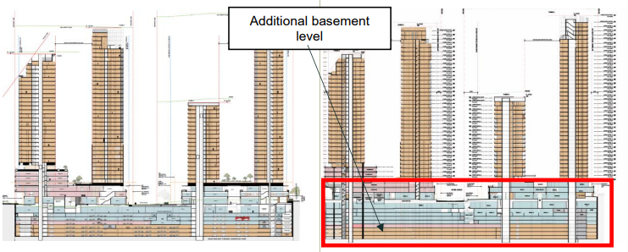
Figure 42 – Extract of applicants submitted modified Section Plan indicating the additional level of basement proposed.
Source: (Statement of Environmental Effects prepared by Gyde Consulting 27 March 2025

- This modification application seeks to expand the childcare centre. The proposal has been modified to support an increase from 100 to 200 children. The modified design allows for 2,509m² of internal space (previously 1,387) and 1,448m² of external space (previously 798m²).
- Notably, as per the Original DA, this modification has only been designed to ensure it can comply with the relevant SEPP criteria and guidelines, including sufficient and appropriate access, parking and outdoor play area spaces. However, given the future operator of the childcare centre is not yet known, its use, operation, and fit-out does not form part of this development application. A separate development application will be required.

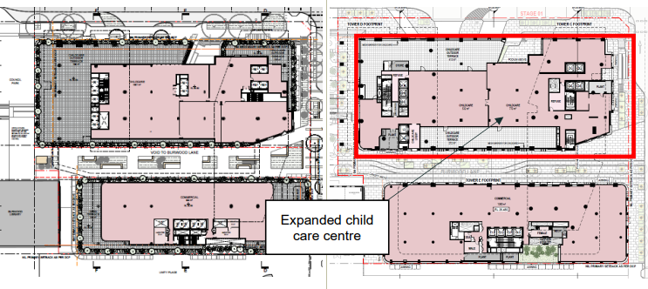
Figure 43 – Extract of applicants submitted modified childcare centre within Block 2.
Source: (Statement of Environmental Effects prepared by Gyde Consulting 27 March 2025

- Maximise retail frontage by relocating retail space along Wynne Avenue. As such this modification application seeks to reconfigure the retail spaces to accommodate the required services.

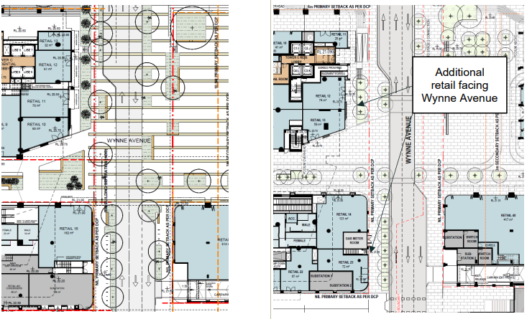
Figure 44 – Extract of the retail tenancies facing Wynee Avenue.
Source: (Statement of Environmental Effects prepared by Gyde Consulting 27 March 2025

Commercial Modifications

- As mentioned earlier within this report, the childcare centre is expanding to allow for an increase in child capacity from 100 to 200 children.

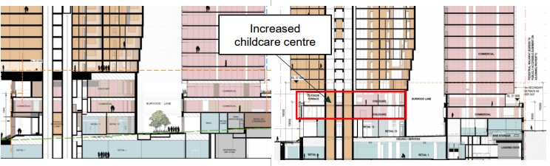
Figure 45 – Extract of the applicants submitted section plans indicating the expanded childcare centre.
Source: (Statement of Environmental Effects prepared by Gyde Consulting 27 March 2025
- Increased the car park exhaust along the sites western boundary from the approved 3m to 6m.

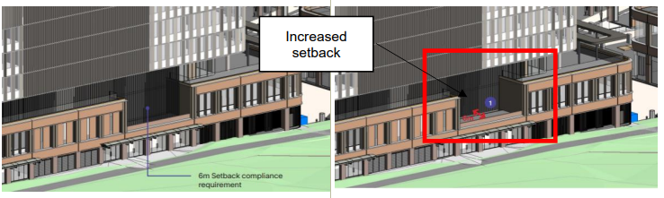
Figure 46 – Extract of the Photomontage diagram indicating the increase setback to accommodate the car park exhaust.
Source: (Statement of Environmental Effects prepared by Gyde Consulting 27 March 2025

- Additional columns are required for structural support to the commercial building (Tower E). Additionally, the façade has been modified (specifically the blade walls) to include penetrations to allow for an outward aspect.

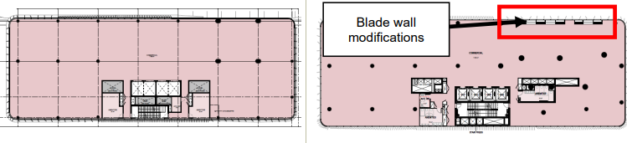
Figure 47 – Extract of the blade wall modifications to Tower E.
Source: (Statement of Environmental Effects prepared by Gyde Consulting 27 March 2025

Conditions to be Modified

Condition | Existing Condition | Proposed Condition
1 | Conditions of Approval | Updated modified plans.
78 | The hours of operation of the Commercial/Retail areas of the development shall generally be 6am to 12 midnight and a separate approval from Council is required for the extension of any these hours of operation. This includes general deliveries and waste management services unless such operations are addressed by any other legislation | It is proposed to amend this condition or include a new condition to allow the Hawkers Market, Car Street and existing approved basement retail to have 24/7 operations

Public Domain Modifications

- The updated plan balances play and adaptability, while carefully placing planters to maintain visibility to ground-floor businesses and support outdoor dining opportunities. The applicant initially proposed removal of the water feature as part of the subject modification. However, following Council’s recommendation, the water feature is now retained.
- Landscape planters along Clarendon Place have been reinstated.
- Circulation and access at the corner of Clarendon Place and Railway Parade have been revised to include stairs and a planter, addressing grading and level changes. These amendments improve equitable and clearly defined access to Tower A, Tower B, and the central plaza.
- Laneway along Tower D, C and E has been redesigned, including amendments to planter layouts to provide more usability for visitors with individual seating opportunities to help activate the laneway. The raised planters have also been used to assist with overland flow paths to minimise trap points which may result in water egress into lobbies and tenancies.
- Wynne Avenue layout amendments have been incorporated, including planter locations and access along Tower C and Wynne Avenue in response to carpark head heights, existing service locations and staging of the project.
- Plant and tree schedule along the ground floor has been amended, to provide for suitable species that will be successful in raised planters, provide a mix of form, height and colour variance to create a positive microclimate and overall look to the public domain.
- Tower B (Level 3 Podium Communal Open Space) has been redesigned in response to the residential amendments outlined earlier in the assessment report.
- Tower D (Level 3 and Level 6 Podium Communal Open Space) has been redesigned in response to the residential amendments outlined earlier in the assessment report.
- The paving specification has been updated to reflect the site's industrial heritage and align with the character of nearby Burwood Library. The new design introduces brick paving that traces "track" lines to support wayfinding and movement, while bluestone remains the primary paving material.
- Street furniture has been updated to include integrated timber benches within raised planters, providing evenly distributed seating for respite. Cycle hoops are strategically placed along Railway Parade for visiting cyclists, with their quantity remaining consistent with the approved DA.

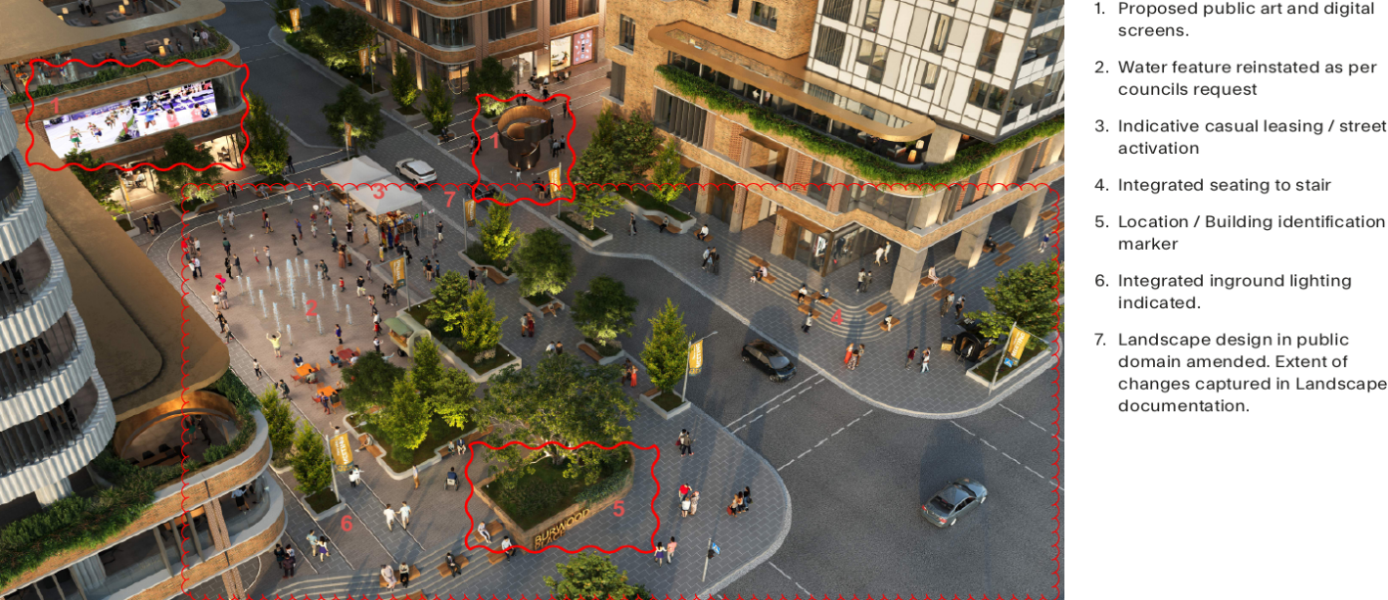
Figure 48 – Extract of applicant’s CGI render of Aerial from Railway Parade (as amended).
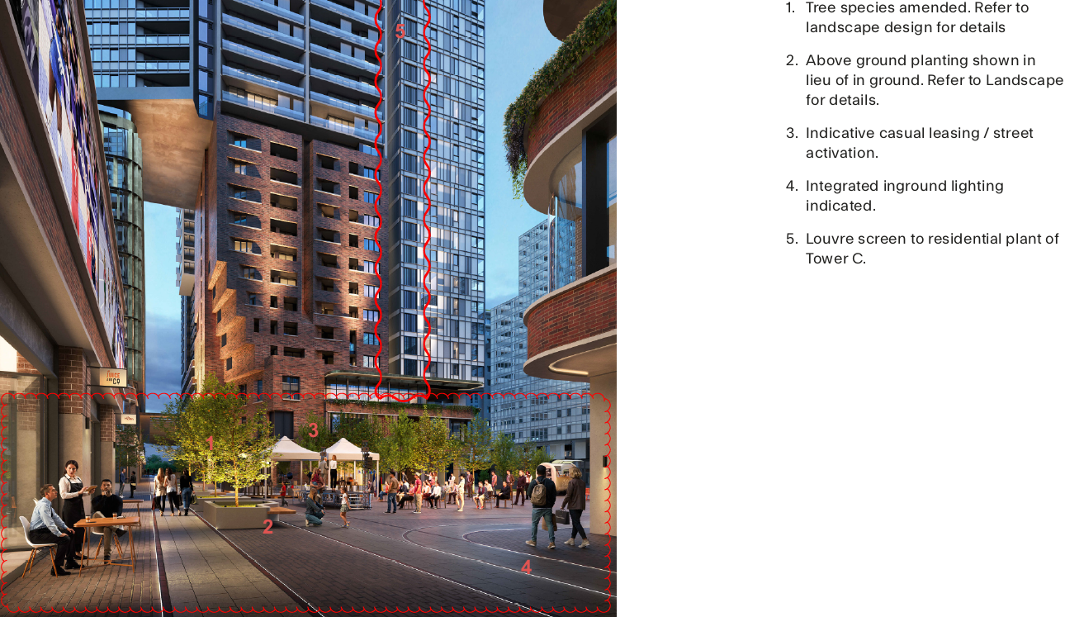
Source: (Studio.SC)
Figure 49 – Extract of applicant’s CGI render of View from Stage 2 Retail Link (as amended).
Source: (Studio.SC)
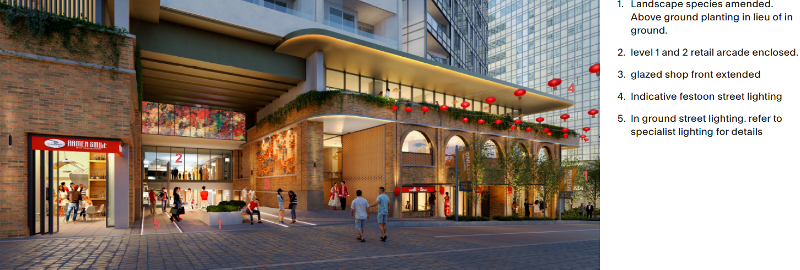
Figure 50 – Extract of applicant’s CGI render of Public Domain Clarendon Place (amended).
Source: (Studio.SC)
2.2 Background

Below is a timeline of the previous applications attributed to the subject site:

DA.2021.44 – lodged with Council on 13 April 2021 seeking consent for “Demolition of the existing structures and the construction of a mixed use development known as ‘Burwood Place” comprising five (5) towers above a three storey podium with 1,041 residential units, 30,044 of non-residential gross floor area for retail, commercial, child care and entertainment/cinema uses, 6-7 levels of basement parking with 1,757 car parking spaces, and public domain areas”. The application was approved by the Sydney Eastern City Planning Panel on 28 November 2022. The consent was issued on 1 December 2022.

DA.2023.32.1 – Modification application for stratum subdivision of land for the purpose of road dedication. The application was approved by Burwood Council on 29 September 2023.

DA.2021.44.2 - Modification application to reinstate the area beneath the land to be acquired by Council for road widening purposes and add such land to the basement area of the development. The application was approved by Burwood Council on 12 October 2024.

DA.2021.44.3 – Modification to amend Condition 27 to change the lead architect to Scott Carver, increase the number of bicycle parking on Level B1 and to change the condition numbering. The application was approved by Burwood Council on 5 February 2024.

DA.2021.44.4 – Modification application to modify Water NSW’s General Terms of Approval, to allow for a drained basement instead of a waterproofed/tanked basement. This application was approved by Burwood Council on 20 March 2025.

The current Section 4.55 (2) Modification Application was lodged on 18 October 2024. A chronology of the application since lodgement is outlined in Table 2.

Table 2: Chronology of the DA

Date | Event
05 November 2024 | DA referred to eight (8) technical teams within Council for review/comment and/or recommended conditions of Development Consent.
14 November 2024 until 30 December 2024 | Exhibition of the application. In response to the public notification of the modification application, three (3) unique submissions were received.
26 November 2024 | DA referred to external agencies (Transport for NSW, Sydney Trains and Water NSW).
17 December 2024 | The application was considered at the Burwood Design Review Panel. The following issues were raised:  Principle 1 – Context and Neighbourhood Character  - The Panel expressed concerns over the public domain offering, amenity within residential levels and impact of proposed changes on the overall facades of the project.  Principle 2 – Built Form and Scale  - Concerns were raised regarding sub-level retail spaces and the need for retail connectivity to the street. The development is to maintain and enhance the public domain. The Panel did not support the shrinking of internal residential corridor spaces and diminishing of sunlight and ventilation. Concerns were also raised with proposed residential balconies.  Principle 3 – Density  - Proposed density is supported, contingent on improvements to the design of the public domain offering.  Principle 4 – Sustainability  - The Panel proposed the inclusion of ceiling fans in all bedrooms and living areas and rainwater tanks, along with the recommendation of including EV charging stations.  Principle 5 – Landscape  - Concerns regarding the diminishing of the quality of the public domain, specifically the loss of street trees, removal of water feature and a reduction in landscape planting. Design concerns were also raised in regard to the proposed modifications to Wynne Avenue, Burwood Lane and Clarence Place.  Principle 7 – Safety  - Balcony depths to be reviewed.  Principle 8 – Housing Diversity and Social Interaction  - Revised plans must confirm layouts of pre- and post-adaptation apartments. Further information needed on wheelchair access for apartments.  Principle 9 – Aesthetics  - It was recommended that local artists should be engaged for installations and mural opportunities. The Panel expressed concerns that the proposed modifications to FSR and roof scape engineering had impacts on the façade, with previously approved design elements and facades diminished through the proposed amendments.  Conclusion  - The Panel did not support the proposal in its form and configuration and was of the view that the proposal should be further developed to be in-line with the recommendations made.
20 December 2024 | A formal Request for Amended Plans/Additional Information was sent to the Applicant following up on previous conversations that the nature of the changes proposed as part of the Section 4.55 Modification Application are not shown using the industry standard of “cloud-like” bubble highlights. The Applicant was requested to submit amended drawings/additional information which clearly show the proposed changes as compared to the originally approved plans.
22 January 2025 | A meeting was undertaken between Council and the applicant to discuss issues relating to the submitted plans and documentation. Amended plans were requested.
30 January 2025 | A briefing meeting was held with the Regional Planning Panel to discuss the application in its entirety.
3 February 2025 | Amended plans and documents were submitted to Council in response to Council’s Request for Information.
20 May 2025 | A second Design Review Panel meeting was held. The following design issues were raised:  Principle 1 – Context and Neighbourhood Character  - Further information was required on how the development considers, responds to and integrates with the surrounding urban context. The inclusion of casual seating on planter walls was recommended.  Principle 2 – Built Form and Scale  - Further design exploration required for the proposed Hawkers Market, particularly in its context to Railway Parade.  Principle 3 – Density  - Proposed density is supported, contingent on improvements to the design of the public domain offering.  Principle 4 – Sustainability  - The Panel proposed the inclusion of ceiling fans in all bedrooms and living areas and rainwater tanks, along with other recommendations for improved sustainability.  Principle 5 – Landscape  - Concerns regarding the proposed landscaping arrangements were raised, specifically the reduction of landscaping in laneway areas, on-slab planting and raised planter boxes. Further information and design amendments were requested to promote tree health, deep soil areas and irrigation and drainage systems. Issues were also raised with the proposed night-time lighting strategy and sun protection measures during summer months.  Principle 6 – Amenity  - An Odour Impact Assessment and Ventilation Assessment were requested for the proposed Hawkers Market. Concerns remain regarding the potential long-term odour accumulation.  Principle 7 – Safety  - NCC compliance for balcony depths required.  Principle 8 – Housing Diversity and Social Interaction  - Revised plans must confirm layouts of pre- and post-adaptation apartments. Further information needed on wheelchair access for apartments.  Principle 9 – Aesthetics  - The need for a revised Public Art Strategy was raised.
11 June 2025 | An additional Request for Information was issued to the applicant raising varying issues surrounding design features and proposed changes to the approved public domain. Specifically, the letter called for additional information relating to the abovementioned Design Review Panel comments, along with the below:  Traffic and Transport  - A Traffic Impact Assessment was requested, particularly in regard to the proposed changes to Wynne Avenue. A swept path analysis was requested for Wynne Avenue and key loading docks. Further information was required on street lighting for the public domain.  Public Domain  - Further information was requested on details of the proposed changes to the public domain, as shown through plans and documentation. Public domain features must be consistent with Condition 141 of the development consent.
3 July 2025 | Amended plans and documents were submitted to Council in response to Council’s Request for Information. The amended plans were assessed and all previous issues raised regarding the changes to the buildings and Hawkers Market have been resolved. However, all other elements of the proposal will not form part of this development consent due to insufficient information being provided.

2.3 Site History

Development Consent No. 44/2021 was issued, in respect of the subject site, on 1 December
2022 for “Demolition of the existing structures and the construction of a mixed-use development known as ‘Burwood Place” comprising five (5) towers above a three storey podium with 1,041 residential units, 30,044m² of non-residential gross floor area for retail, commercial, childcare and entertainment/cinema uses, 6-7 levels of basement parking with 1,757 car parking spaces, and public domain areas”.

The property adjoining the subject site to the west at No’s 2-4 Conder Street, Burwood is owned by Council. Development Consent No. 2022/44 was issued on 16 March, 2023 for the “Burwood Urban Park and Cultural Centre including public plaza, café, landscaping and public domain upgrades, basement carparking and other associated works”.

3. STATUTORY CONSIDERATIONS

Section 4.55 Modifications of Consents

The subject S.4.55(2) Modification Application seeks consent for modifications to the approved Development Application (DA) DA.2021.44. Amendments include the reconfiguration of residential and retail components, the introduction of a hawker’s market, and extended operating hours are proposed to allow for 24 hours, 7 days a week trading for retail uses, and modifications of Conditions 1 and 78.

The proposed modification to development consent DA.2021.44 is sought pursuant to Section 4.55(2) of the Act. In accordance with Section 4.55(2) of the Act the Consent Authority must consider:

(2) Other modifications: A consent authority may, on application being made by the applicant or any other person entitled to act on a consent granted by the consent authority and subject to and in accordance with the regulations, modify the consent if—

- it is satisfied that the development to which the consent as modified relates is substantially the same development as the development for which the consent was originally granted and before that consent as originally granted was modified (if at all), and

Comment: The proposed Section 4.55(2) application seeks amendments which include the reconfiguration of residential and retail components, the introduction of a hawker’s market, and extended operating hours are proposed to allow for 24 hours, 7 days a week trading for retail uses, and modifications of Conditions 1 and 78.

The proposed modifications will retain the same approved land use/type of development, and will not have any discernible impact on the site, adjoining properties and the locality. The proposed modifications are considered to be substantially the same development for the following reasons:

- Number of residential units remains unchanged: The proposed modifications do not introduce any additional residential apartments to the proposed development. As such, the overall density and character of the residential component of the development remains unchanged.
- Gross Floor Area: The proposed modifications do not result in an increase to the overall GFA on the site but involve a redistribution of this space. This approach is consistent with the BLEP’s FSR controls, ensuring compliance while optimising the layout without altering the fundamental scale of the development.
- Parking: The modifications result in a minor increase in the number of parking spaces. This outcome is attributed to the revised mix of residential apartments, the inclusion of Council’s 40 parking spaces under the VPA, and the addition of retail and childcare facilities. Notwithstanding this increase, the parking strategy remains consistent with the approved development, appropriately addressing the site’s needs without expanding its footprint or density.
- Tower B Height: A 2.1-metre height increase is proposed for Tower B to accommodate essential plant equipment. The proposal remains within the BLEP’s permissible height controls and does not result in any material change to the visual impact, bulk, or scale of the tower.
- Additional Basement Level for Retail: The introduction of an additional basement level is proposed to accommodate further retail space in response to current market demand. This modification enhances the commercial viability of the development while maintaining the overall structure and intent of the approved proposal.

In summary, the proposed modifications do not materially alter the form, scale, or character of the approved development. The amendments represent refinements that enhance the functionality and viability of the development while maintaining consistency with applicable planning controls. Accordingly, it is considered that the development, as modified, constitutes substantially the same development as originally approved, in accordance with Section 4.55 of the Environmental Planning and Assessment Act 1979.

- It has consulted with the relevant Minister, public authority or approval body (within the meaning of (Division 4.8) in respect of a condition imposed as a requirement of a concurrence to the consent or in accordance with the general terms of an approval proposed to be granted by the approval body and that Minister, authority or body has not, within 21 days after being consulted, objected to the modification of that consent and

- it has notified the application in accordance with –
- the regulations, if the regulations so require, or
- a development control plan, if the consent authority is a council that has made a development control plan that requires the notification or advertising of applications for modifications of a development consent, and

- It has considered any submissions made concerning the proposed modification within any period prescribed by regulations or provided by the development control plan, as the case may be.

Comment: The development application was placed on public notification. In response to the public notification of the DA, three (3) submissions were received. Issues detailed within the submissions are discussed later within this report under Community Consultation

(3) In determining an application for modification of a consent under this section, the consent authority must take into consideration such of the matters referred to in section 4.15(1) as are of relevance to the development the subject of the application. The consent authority must also take into consideration the reasons given by the consent authority for the grant of the consent that is sought to be modified.

Comment: An assessment of the proposal having regard to the matters referred to in Section 4.15(1) of the Act is contained below:

When determining a development application, the consent authority must take into consideration the matters outlined in Section 4.15(1) of the Environmental Planning and Assessment Act 1979 (‘EP&A Act’). These matters as are of relevance to the development application include the following:

- the provisions of any environmental planning instrument, proposed instrument, development control plan, planning agreement and the regulations
- any environmental planning instrument, and
- any proposed instrument that is or has been the subject of public consultation under this Act and that has been notified to the consent authority (unless the Planning Secretary has notified the consent authority that the making of the proposed instrument has been deferred indefinitely or has not been approved), and
- any development control plan, and
(iiia) any planning agreement that has been entered into under section 7.4, or any draft planning agreement that a developer has offered to enter into under Section 7.4 and
- the regulations (to the extent that they prescribe matters for the purposes of this paragraph), that apply to the land to which the development application relates,
- the likely impacts of that development, including environmental impacts on both the natural and built environments, and social and economic impacts in the locality,
- the suitability of the site for the development,
- any submissions made in accordance with this Act or the regulations,
- the public interest.

These matters are further considered below.

3.1 Environmental Planning Instruments, proposed instrument, development control plan, planning agreement and the regulations

The relevant environmental planning instruments, proposed instruments, development control plans, planning agreements and the matters for consideration under the Regulation are considered below.

- Section 4.15(1)(a)(i) – Provisions of Environmental Planning Instruments

The following Environmental Planning Instruments are relevant to this application:

- State Environmental Planning Policy (Sustainable Buildings) 2022
- State Environmental Planning Policy (Resilience & Hazards)
- State Environmental Planning Policy (Biodiversity & Conservation) 2021
- State Environmental Planning Policy (Housing) 2021
- State Environmental Planning Policy (Planning Systems) 2021
- State Environmental Planning Policy (Transport and Infrastructure) 2021
- Burwood Local Environmental Plan 2012
- Burwood Development Control Plan 2013

A summary of the key matters for consideration arising from these State Environmental Planning Policies are outlined in Table 3 and considered in more detail below.

Table 3: Summary of Applicable Environmental Planning Instruments

Control | Approved Development | Comply (Y/N)
State Environmental Planning Policy (Sustainable Buildings) 2022 | No compliance issues identified subject to imposition of conditions on any consent granted. | Y
State  Environmental Planning Policy (Resilience & Hazards) | Chapter 4: Remediation of Land  - Section 4.6 – Contamination and remediation to be considered in determining development applications. | Y
State Environmental Planning Policy (Biodiversity & Conservation) 2021 | Chapter 2: Vegetation in non-rural areas was addressed in the original assessment of the DA. | N/A
State  Environmental Planning Policy (Planning  Systems) 2021 | Chapter 2: State and Regional Development  - Section 2.19(1) declares the proposal regionally significant development pursuant to Clause 2 – General development over $30 million and Clause 3 – Council related development over $5 million of Schedule 6. | Y
State  Environmental Planning Policy (Transport and Infrastructure) 2021 | Chapter 2: Infrastructure  - Section 2.48 – Determination of Development Applications. | Y
State  Environmental Planning Policy (Housing) 2021 | Chapter 4: Design Quality of Residential Apartment Development. | Y
Burwood Local Environmental Plan 2012 | Clause 2.3 – Permissibility and zone objectives.  Clause 4.3 – Height of Buildings  Clause 4.4 – Floor Space Ratio  Clause 6.1 - Acid Sulfate Soils  Clause 6.5 – Design Excellence in Zones E1 and MU1. | Y

Consideration of the relevant SEPPs is outlined below:

- State Environmental Planning Policy (Sustainable Buildings) 2022

The aims of the SEPP encourage design and construction of more sustainable buildings across NSW. Chapter 2 prescribes standards for residential development that is considered BASIX development.

State Environmental Planning Policy (Sustainable Buildings) 2022 applies to the development as the residential component of the proposal as modified is BASIX affected development.
The proposed development includes BASIX affected buildings. The following BASIX Certificates has been submitted with the application as modified:

Tower A – BASIX Certificate No. 1131316M_05
Tower B – BASIX Certificate No. 1139367M_04
Tower C – BASIX Certificate No. 1127670M_03
Tower D – BASIX Certificate No. 1156324M_04

The environmentally sustainable commitments within the BASIX certificates will be required to be fulfilled as a prescribed condition of consent. Accordingly, it is proposed to include the BASIX Certificates in the approval documents.

- State Environmental Planning Policy (Resilience and Hazards) 2021

The provisions of SEPP (Resilience and Hazards) 2021 are required to be considered for any development application. Consideration must be made if the land is suitable for the proposed development, if it is contaminated, if it is suitable for the proposed use, and/or of the contamination is required to be remediated before the land is used for that purpose.

The issue of contamination and remediation of land was considered as part of the assessment of the original Development Application (No.2021/44). A number of conditions were imposed on Development Consent No.2021/44 issued on 1 December, 2022 to address these requirements.

- State Environmental Planning Policy (Biodiversity & Conservation) 2021

The Vegetation SEPP commenced on 25 August 2017 and replaced clause 5.9 of BLEP 2012, which related to the preservation of trees and vegetation. The objective of the SEPP is to protect the biodiversity values of trees and other vegetation and to preserve the amenity of the area through the preservation of trees and other vegetation.

This proposed Section 4.55(2) modification application does not seek the removal of any significant vegetation at the subject site. All existing vegetation at the subject site that was sought for removal, was considered in the original assessment of the application.

- State Environmental Planning Policy (Planning Systems) 2021 (Planning Systems SEPP)

The proposal as modified is regionally significant development pursuant to Section 2.19(1) as it meets the criteria in Clause 2 of Schedule 6 of the Planning Systems SEPP as the proposal is Council related development with a capital investment value of more than $30 million. Accordingly, the Sydney Eastern City Planning Panel is the consent authority for the application. The proposal is consistent with this Policy.

- State Environmental Planning Policy (Transport and Infrastructure) 2021

The aim of this chapter is to facilitate the effective delivery of infrastructure across the State. The SEPP provides development controls for various land uses and activities. It also addresses the consideration of railways and provides provisions for development in or adjacent to rail corridors and interim rail corridors. Section 4.55 (2) Page 52 Schedule 3 of the SEPP outlines triggers for traffic generating development.

Additional retail areas are proposed under this modification. However, given the redistribution of GFA, there is no increase in GFA across the site. Additionally, there is a reduction in the overall non-residential GFA being provided, specifically the original DA included 48,534m² and this modification proposes 44,995m² of non-residential GFA.

Notably, the proposal was referred to Sydney Trains for comment in accordance with Section 2.98 of State Environmental Planning Policy (Transport and Infrastructure) 2021. Accordingly, no objections were raised, subject to conditions.

In addition to the above, the proposal has a frontage to Railway Parade, which is a classified road under the control of Burwood Council. The proposal as modified was referred to Transport for NSW for comment. In their referral response issued on 27 November 2024, it was advised that the proposed modifications to DA.2021.44 will not have any detrimental impact on the surrounding classified road network. Subsequently no objections were raised.

- State Environmental Planning Policy (Housing) 2021

Chapter 4 of State Environmental Planning Policy (Housing) 2021 aims to improve the design quality of residential apartment development. Schedule 9 of the SEPP introduces nine (9) design quality principles. The design quality principles provide a guide to achieving good design.

Design Quality Principles

The proposal as modified has been assessed against the Design Quality Principles. The proposal is considered to be consistent with the following Design Quality Principles.

Principle 1: Context and Neighbourhood Character

Good design responds and contributes to its context. Context is the key natural and built features of an area, their relationship and the character they create when combined. It also includes social, economic, health and environmental conditions.

Responding to context involves identifying the desirable elements of an area’s existing or future character. Well-designed buildings respond to and enhance the qualities and identity of the area including the adjacent sites, streetscape and neighbourhood.

Consideration of local context is important for all sites, including sites in established areas, those undergoing change or identified for change.

Response: The proposal as modified remains consistent with the approved DA in its podium expression, through-site links, and materiality. These elements continue to reinforce a human-scaled relationship with the street while enabling slender towers to integrate seamlessly within the skyline.

Burwood is identified as a key precinct within Sydney’s night-time economy, with Council designating part of the town centre as a future Special Entertainment Precinct anchored by Chinatown and Emerald Square. The inclusion of a hawkers market within the podium supports this role by introducing an additional layer of cultural and culinary activity. This will activate the precinct after hours, enhance pedestrian connectivity, and further strengthen Burwood’s identity as a vibrant and diverse urban destination.
Principle 2: Built Form and Scale

Good design achieves a scale, bulk and height appropriate to the existing or desired future character of the street and surrounding buildings.

Good design also achieves an appropriate built form for a site and the building’s purpose in terms of building alignments, proportions, building type, articulation and the manipulation of building elements.

Appropriate built form defines the public domain, contributes to the character of streetscapes and parks, including their views and vistas, and provides internal amenity and outlook.

Response: The proposal as modified remains consistent with the original DA approval, with only minor amendments proposed under this modification. The changes are wholly contained within the site-specific DCP provisions for height, FSR, building separation and setbacks, thereby retaining the approved built form strategy. The podium maintains a human-scaled interface to the street, while the towers continue to reinforce the high-density character envisaged for the Burwood Strategic Centre. The proposal is consistent with the endorsed planning controls and delivers a built form of appropriate scale and bulk for this prominent site."

Density

Good design achieves an appropriate built form for a site and the building’s purpose, in terms of building alignments, proportions, building type and the manipulation of building elements.

Appropriate built form defines the public domain, contributes to the character of streetscapes and parks, including their views and vistas, and provides internal amenity and outlook.

Response: The proposal as modified maintains the approved residential density, retaining the overall number of apartments. Minor adjustments to the dwelling mix have been made, increasing the proportion of larger two- and three-bedroom units in response to demand for family-oriented housing within the Burwood Town Centre. Communal amenity has been enhanced through the provision of additional shared spaces on the upper levels of Towers A and C, offering elevated district views. Recreational facilities have also been improved, with pool areas directly connected to landscaped podiums to strengthen integration and permeability between towers, thereby ensuring a high level of residential amenity.

Principle 4: Sustainability

Good design combines positive environmental, social and economic outcomes. Good sustainable design includes use of natural cross ventilation and sunlight for the amenity and liveability of residents and passive thermal design for ventilation, heating and cooling reducing reliance on technology and operation costs. Other elements include recycling and reuse of materials and waste, use of sustainable materials and deep soil zones for groundwater recharge and vegetation.

Response: The proposal as modified remains consistent with the DA approval, maintaining compliance with BASIX and the solar access requirements of the ADG. The waste management strategy has been refined through the inclusion of an additional recycling chute, supporting improved long-term operational outcomes. The residential component has transitioned to an all-electric building, contributing to more sustainable energy use. Cross-ventilation outcomes remain consistent with the approved scheme. The updated performance is: Block 1 – 60% (Tower A 61%, Tower B 60%); Block 2 – 60% (Tower C 67%, Tower D 44%). The minor reduction in overall percentage is attributable to the removal of plenums from each floor plate to improve constructability and coordination.

Principle 5: Landscape

Good design recognises that together landscape and buildings operate as an integrated and sustainable system, resulting in attractive developments with good amenity. A positive image and contextual fit of well-designed developments is achieved by contributing to the landscape character of the streetscape and neighbourhood.

Good landscape design enhances the development’s environmental performance by retaining positive natural features which contribute to the local context, coordinating water and soil management, solar access, micro-climate, tree canopy, habitat values and preserving green networks.

Good landscape design optimises usability, privacy and opportunities for social interaction, equitable access, respect for neighbours’ amenity and provides for practical establishment and long term management

Response: The landscape strategy remains generally consistent with the DA approval, with no changes to the location or extent of through-site links or publicly accessible open spaces. The proposed refinements focus on enhancing amenity, including the introduction of a more flexible plaza space capable of accommodating a range of events and community uses. Tree canopy cover is maintained in accordance with the approval, providing shade and comfort within key public areas. The Public Art Strategy remains secured as a condition of consent and will be further developed and integrated at detailed design stage to reinforce the quality and identity of the public realm.

Principle 6: Amenity

Good design positively influences internal and external amenity for residents and neighbours. Achieving good amenity contributes to positive living environments and resident wellbeing.

Good amenity combines appropriate room dimensions and shapes, access to sunlight, natural ventilation, outlook, visual and acoustic privacy, storage, indoor and outdoor space, efficient layouts and service areas and ease of access for all age groups and degrees of mobility.

Response: The proposal as modified remains consistent with the original DA approval with regard to amenity.

Principle 7: Safety

Good design optimises safety and security within the development and the public domain. It provides for quality public and private spaces that are clearly defined and fit for the intended purpose. Opportunities to maximise passive surveillance of public and communal areas promote safety.

A positive relationship between public and private spaces is achieved through clearly defined secure access points and well-lit and visible areas that are easily maintained and appropriate to the location and purpose.

Response: The proposal as modified remains consistent with the DA approval, with no changes affecting the original CPTED principles or the findings of the Crime Risk Report. The development continues to deliver a high level of safety and security through active frontages, clear sightlines, and well-lit public spaces, in accordance with conditions of consent to be addressed at subsequent stages.

Principle 8: Housing Diversity and Social Interaction

Good design achieves a mix of apartment sizes, providing housing choice for different demographics, living needs and household budgets.

Well-designed apartment developments respond to social context by providing housing and facilities to suit the existing and future social mix. Good design involves practical and flexible features, including different types of communal spaces for a broad range of people, providing opportunities for social interaction amongst residents.

Response: The proposal as modified continues to provide a diverse mix of dwelling types, comprising 1, 2, and 3 bedroom units. While the total number of apartments remains unchanged, the revised mix increases the proportion of larger two- and three-bedroom units, addressing growing demand for family-oriented housing in town centres. Research by the Greater Sydney Commission and the NSW Department of Planning underscores the importance of providing larger apartments within Strategic Centres to support long-term housing choice, attract and retain families, and promote sustainable urban living in proximity to transport, employment, and services. This mix continues to accommodate smaller households while enhancing the availability of family-suitable dwellings, thereby contributing to social balance and resilience within the precinct

Principle 9: Aesthetics

Good design achieves a built form that has good proportions and a balanced composition of elements, reflecting the internal layout and structure. Good design uses a variety of materials, colours and textures. The visual appearance of a well-designed apartment development responds to the existing or future local context, particularly desirable elements and repetitions of the streetscape.

Response: The proposal remains consistent with the DA approval, with no changes to the approved materiality or architectural language. The development continues to deliver a high-quality aesthetic outcome, featuring brick podiums that respond to the character of Burwood Road and articulated through elements such as hit-and-miss brickwork, vertical louvres, portal frames, corner windows, shopfront awnings, balconies, and terraces. Each tower maintains a distinct approach to fenestration and expression, ensuring visual diversity while achieving cohesion across the precinct.

Apartment Design Guide (ADG)

As the proposed development contains a residential flat building of three or more storeys and four or more dwellings, the provisions of the Apartment Design Guide (ADG) are applicable. The ADG contains objectives, design criteria and design guidelines for residential apartment development. The proposed development as modified has been assessed against the relevant key design criteria within Parts 3 and 4 of the ADG in Table 2 below:

Objective | Requirement | Approved | Proposed | Compliance
3D  Communal Open Space | Communal open space has a minimum area equal to 25% of the site | Block 1 (Tower A and Tower B) – 2350.5m²  Block 2 (Tower C and Tower D) – 2531.5m² | Block 1 (Tower A and Tower B) – 2350.5m² – No Change.  Block 2 (Tower C and Tower D) –2531.5m² – No change. | Yes
3D Communal Open Space | Developments achieve a minimum of 50% direct sunlight to the principal usable part of the communal open space for a minimum of 2 hours between 9 am and 3 pm on 21 June (mid-winter) | Block 1 (Tower A and Tower B)  Block 1 Principal Area 1 = More than 50% of the area received sunlight access for 1 hour and 31 minutes of solar access between 11.15am and 12.46pm  Block 2 (Tower C and Tower D)  Block 2 Principal Area 2 = More than 50% of the area received sunlight access for 2 hours and 1 minute between 11.28 and 1.29pm.  Block 2 Principal Area 3 = More than 50% of the area received sunlight access for a minimum of 3 hours between 9am and 12pm.  Block 2 Principal Area 4 = More than 50% of the area received sunlight access for a minimum of two (2) hours between 1.00pm and 3.00pm. | No change proposed. | Yes
3E  Deep Soil Zones | Communal open space has a minimum area equal to 25% of the site. | No deep soil proposed as part of the original DA approval. | No change proposed when compared to the approved DA. | N/A
3F  Visual Privacy | The ADG prescribes minimum separation distances between buildings:  - Up to 12m (4 storeys) - 6m (habitable) / 3m (non-habitable)  - Up to 25m (5-8 storeys) - 9m (Habitable) / 4.5m (non-habitable)  - Over 25m (9+ storeys) - 12m (Habitable) / 6m (non-habitable)  No separation is required between blank walls. | Compliant separation distances proposed between all towers. | No change proposed as part of this Section 4.55(2) modification application. | N/A
4A Solar Access | Living rooms and private open space areas of at least 70% of apartments receive a minimum of 2 hours direct sunlight between 9am and 3pm at mid-winter. | Block 1 Tower A – 82%  Block 1 Tower B – 51%  Block 1 total – 72%  Block 2 Tower C – 67%  Block 2 Tower D – 78%  Total – 71% | Block 1 Tower A – 77%  Block 1 Tower B – 57%  Block 1 total – 70%  Block 2 Tower C – 68%  Block 2 Tower D – 74%  Total – 71% | Yes
4B  Natural Ventilation | At least 60% of apartments are naturally cross ventilated in the first nine storeys of the building. Apartments at ten storeys or greater are deemed to be cross ventilated | Block 1 Tower A – 64%  Block 1 Tower B – 64%  Block 1 total – 64%  Block 2 Tower C – 65%  Block 2 Tower D – 66%  Total – 65.4% | Block 1 Tower A – 60%  Block 1 Tower B – 61%  Block 1 total – 60%  Block 2 Tower C – 67%  Block 2 Tower D – 44%  Total – 60% | Yes
4D  Apartment Size and Layout | Apartments are required to have the following minimum internal areas:  Studios: 35m²  1 bedroom: 50m²  2 bedroom: 70m²  3 bedroom: 90m² | All apartments comply with the minimum requirements. | All units meet the minimum area requirement with the exception of:  Tower C ‐ Apartment 2 BED J ‐ 24 apartments ‐ 73m² (ADG requires 75m²), inclusive of an additional bathroom.  Tower D ‐ Apartment 3 BED A ‐ 21 Apartments ‐ 92m² (ADG requires 95m² inclusive of an additional bathroom).  This represents a variation of 2.3% for the 2-bedroom apartments and a 3% variation for the 3 bedroom apartments (inclusive of a bathroom), which is considered minor. | No - Justifiable
4E Private Open Space and Balconies | All apartments are required to have primary balconies as follows:  1 bedroom apartments: 8m² minimum area, 2m minimum depth.  2 bedroom apartments: 10m² minimum area, 2m minimum depth.  3+ bedroom apartments: 12m² minimum area, 2.4m minimum depth.  Ground level or podium apartments are to have a minimum POS area of 15m² and minimum depth of 3m. | In general, minimum depths achieved except in apartment TD‐xx02 In this case the depth of the 3 Bedroom apartment was 2 metres.  To compensate this, the total area of the main balcony was 14 m² and a secondary balcony of 4 m² related to the main bedroom was provided. | The majority of balconies comply with the minimum guidelines. Where compliance is not achieved (in particular the 3 bedroom apartments where the depth is 2 metres) the total area of the main balcony is increased from the minimum.  In addition, the proposal was referred to Council’s Urban Design Officer for comment. In their referral response, no objections were raised. | Yes
4F Common Circulation and Spaces | For buildings of 10 storeys and over, the maximum number of apartments sharing a single lift is 40.  Where design criteria 1 is not achieved, no more than 12 apartments should be provided off a circulation core on a single level. | A single central core serves each of the towers. The number of apartments per level varies. The top levels only have 2-4 apartments while the typical level vary between 8 and 11 depending on the level and the tower.  All lifts have been designed to allow a bigger number of population than a standard lift and both of them can be used for the resident.  Lift numbers were confirmed by Elevator Project Management.  “With regards to the proposed vertical transportation application, the findings of this report, from the information reviewed and technical design works completed to date, support the proposed concept and design of the lifting solution to deliver a high level of lift performance, tenant experience and aligns with industry best practice for sustainability and efficient power consumption technologies, whilst meeting the relevant Australian Standards and recognized industry codes. | A Vertical Transportation Report has been prepared by Kone and provided at Appendix 16. The report outlines the following for each tower:  Tower A: Two lifts will serve up to Level 34, with a double height machine room at Levels 36 and 37. All four lifts will operate at a speed of 4m/sec with overhead machine rooms.  Tower B: Three lifts in a triplex group will serve all populated floors.  Tower C: Two lifts will serve up to Level 34, with their speed increased to 3.5m/sec. These lifts will have side machine rooms, requiring a headroom of 6700mm and a side machine room height of 4500mm.  Tower D: Three lifts in total. Traffic analysis was conducted based on office environment people flow patterns using conventional control (3 lifts in total).  Tower E: Two lifts in total. Entry bias at Levels B5 and G has been considered for commercial lifts traffic analysis.  Kone concludes that the proposed number of lifts is supportable. The lift configuration aims to deliver lift performance and tenant experience, aligning with industry best practises for sustainability and efficient power consumption technologies, while also meeting relevant Australian Standard and recognised Industry Codes. | Yes
4G Storage | In addition to storage in kitchens. Bathrooms and bedrooms, the following storage is provided:  Studio – 4m³  1 Bed – 6m³  2 Bed – 8m³  3 bed – 10m³ | Compliant levels of storage provided. | Added storage has been provided in apartments where possible with the integration of study nooks that can be used for additional storage. | Yes

Burwood Local Environmental Plan 2012

The Burwood Local Environmental Plan 2012 came into effect on 9 November 2012. Burwood LEP 2012 contains a number of controls including numerical development standards which apply to the proposed development. A summary of the assessment of the application against the relevant planning controls within LEP 2012 is shown in Table 3 below.

Burwood LEP 2012 | Proposal | Compliance
4.3(2) Height
Block 1 – 144m | Original Proposal  Tower A – 144m  Tower B - 79m  Proposal as Modified  Tower A – No change proposed.  Tower B – has increased by 2.1m to 81.1m, which is still below the permissible 144m height control. | Yes
4.3(2) Height
Block 2 – 136m | Original Proposal  Tower C – 144m  Tower D - 79m  Tower E – 50.60m  Proposal as Modified  Tower C – No change proposed.  Tower D – No change proposed.  Tower E – No change proposed. | Yes
4.3(2) Height
Wynne Avenue – 136m | No buildings proposed above Wynne Avenue. | Yes
4.3A(2) Exceptions to height of buildings
Despite clause 4.3, the height of a building on land marked “Area A” on the Height of Buildings Map is not to exceed the building height plane for that land. | The proposed development as modified does not exceed the building height plane. | Yes
4.4(2) FSR
Block 1 and Block 2 - 10.54:1 | Original Proposal  Approved GFA – 151,012m²  Approved FSR – 10.51:1  Proposal as Modified  Proposed GFA – 146,035m²  Proposed FSR – 10.17:1 | Yes
4.4(2) FSR
Wynne Avenue – 10.54:1 | Original Proposal  Approved GFA – 1,165m²  Approved FSR – 0.93:1  Proposal as Modified  Proposed GFA – 1,309m²  Proposed FSR – 1:1 | Yes
4.4A(3) FSR
Despite clause 4.4, the ratio of the gross floor area of any part of a building used for the purpose of residential accommodation to the site area must not exceed:  - 2.0:1 – if the building is on land in Area 1,  - 3.0:1 if the building is on land in Area 2,  - 2.7:1 – if the building is on land in Area 3,  - 2.3:1 – if the building is on land in Area 4,  - 2.2:1 – if the building is on land in Area 5,  - 1.4:1 – if the building is on land in Area 6.  - 0.2:1 – if the building is on land in Area 7.  - 1.8:1 – if the building is on land in Area 8.  - 7.16:1 – if the building is on land in Area 9. | The subject site is located within “Area 9” on the Floor Space Ratio Map. Therefore, despite Clause 4.4, the ratio of the gross floor area of any part of a building used for the purposes of residential accommodation to the site area must not exceed 7.16:1, and the gross floor area of any part of a building used for the purpose of serviced apartments to the site area must not exceed 1.054:1.  Further, pursuant to clause 4.4A(10), for the purposes of applying a floor space ratio to development on land in Area 9, including development for a purpose mentioned in subclause (3) or (4) – “Lot 1, DP 577368 and Lot 16 832440 are, despite clause 4.5(3)(b) taken to be a single site area, and The site area is taken to include land that – Is dedicated to council for a public purpose or otherwise set aside as publicly accessible open space, and would have been part of the site area lift had not been dedicated or set aside.”  The proposal provides a total of 102,832m² GFA of residential accommodation within Area 9, which equates to an FSR of 7.16:1 and therefore complies. | Yes
5.1A Development on land intended to be acquired for public purposes.
This clause applies to land shown on the Land Reservation Acquisition Map and specified in Column 1 of the table to this clause and that has not been acquired by the relevant authority of the State specified for the land in Clause 5.1. | Stratum subdivision has been approved for the land reserved for acquisition along Railway Parade. The subdivision included the surface of the reserved land (as outlined in the BLEP’s land acquisition map). It is intended that this new lot (Lot 11) is to be dedicated to Council and the land beneath the stratum subdivision (Lot 10) will remain in the ownership of the applicant.  The development has been setback from Lot 11 and complies with this clause. The approval of the stratum subdivision application (ref: 10.2023.32.1), allows the land (beneath Lot 11) to be redeveloped.  The approval of modification 10.2021.44.2, reinstate the basement area beneath Lot 11, which is compliant with this clause. The proposed amendments are consistent with the approved modification and also extends the basement underneath Lot 11 | Yes
5.10 Heritage Conservation
(1) Objectives The objectives of this clause are as follows—  (a) to conserve the environmental heritage of Burwood,  (b) to conserve the heritage significance of heritage items and heritage conservation areas, including associated fabric, settings and views,  (c) to conserve archaeological sites,  (d) to conserve Aboriginal objects and Aboriginal places of heritage significance. | The Council land, in particular the Burwood Library (“I47”), is a heritage item of local significance, listed within Schedule 5 of the BLEP 2012. The site is also in the vicinity of several other heritage items. Given the nature of the modifications, there is no impact on surrounding heritage items. | Yes
6.1 Acid Sulfate Soils
(1) The objective of this clause is to ensure that development does not disturb, expose or drain acid sulfate soils and cause environmental damage. | The subject site is affected by Class 5 Acid Sulfate Soils. However, there are no works proposed within 500m of adjacent Class 1, 2, 3 or 4 land that is below 5 metres Australian Height Datum and by which the water table is likely to be lowered below 1 metre Australian height Datum. | Yes
6.2 Flood Planning
(1) The objectives of this clause are as follows—  - to minimise the flood risk to life and property associated with the use of land,  - to allow development on land that is compatible with the land’s flood hazard, taking into account projected changes as a result of climate change,  - to avoid significant adverse impacts on flood behaviour and the environment. | The proposed modifications do not alter the flooding assessment undertaken as part of the original DA. Condition 32—36 of the original DA, requires compliance with certain flooding levels and the preparation of a flood risk management and flood emergency evacuation plan, which will be complied with to ensure compliance with this clause of the LEP. | Yes
6.3 Active street frontages
The objectives of this clause is to promote uses that attract pedestrian traffic along certain ground floor street frontages in Zone B4 Mixed Use. | As shown on the Active Street Frontages Map, an active frontage is required along the Block 1 Railway Parade frontage (refer to Figure 16). As detailed in the Amended Architectural Plans, this frontage provides for full activation with 5 retail tenancies, entrances to residential lobbies, new through site links and a new plaza area on the corner of Railway Parade and Wynne Avenue | Yes
6.5 Design Excellence in Zones E1 and MU1
The objective of this clause is to deliver the highest standard of architectural, landscape and urban design. | Condition 27 of the consent requires the development to be referred to the Council’s design integrity panel during the detailed design phase to ensure the design maintains its excellence. Therefore, ongoing compliance with this condition is necessary. The proposed amendments will also need to be reviewed by the panel to ensure they meet the requirements for design excellence. | Yes

Burwood Development Control Plan 2013

The Burwood Development Control Plan 2013 (BDCP),applies to the proposed development, including the Site Specific DCP for 42-50 Railway Parade. A summary of the assessment of the application against the relevant site specific DCP planning controls and objectives within BDCP is shown in Table 4 below:

Burwood DCP 2013 | Proposed | Compliance
Site Planning
P1) Future buildings will generally be located as shown in Figure 2 (subject to detailed design), which includes:  - Two tower building envelopes on Block 1.  - Three tower building envelopes on Block 2.  P2) Development under Wynne Avenue is subject to obtaining owner’s consent and an agreement detailing the precise parameters and extent of the Wynne Avenue use. Council shall be satisfied that any use or development of public land serves the wider community interest and/or results in the provision of commensurate public benefits.  P3) Development of Block 1 shall facilitate the dedication of a 4 metre strip of land alongside Railway Parade (as shown on the Land Reservation Acquisition Map of the BLEP) to Council.  P4) Development of Block 1 shall facilitate public access along Clarendon Place for the purpose of a new footpath and road widening in accordance with the locations outlined in Figure 3.  P5) Development is permitted underneath any footpath or area to be used for road widening, only if it is located within the existing site boundary, as illustrated in Figure 1. For avoidance of doubt, development is permitted under Wynne Avenue, subject to obtaining owner’s consent and approval from Council. | "The location of the podium and tower envelopes remains unchanged. Accordingly, the proposed amendments continue to align with the approved development and the relevant provisions of this section of the DCP. | Yes
Landscaping and Publicly Accessible Land
P9) Landscaping shall be provided within publicly accessible private land. A minimum of 20% of the publicly accessible private land shall comprise ‘soft’ landscaping. For the avoidance of doubt, planter boxes and raised plant beds shall be included in this landscaping calculation.  P12) The development shall provide for communal open space and landscaped areas on the top of podium levels.  P13) Communal open space shall equate to 25% of the area used for the purpose of residential towers and podiums (i.e. the site excluding land dedicated for publicly accessible private land as shown in Figure 4 and commercial development).  P14) At least 50% of the podium and Tower E roof shall be vegetated with grasses, shrubs and trees. | Fourteen percent of the publicly accessible private land is provided as landscaped area. The original DA proposed a compliant 20% landscaping provision, which was subsequently reduced in response to feedback from Council’s Design Review Panel. The proposed amendments generally align with the Panel’s requirements.  The proposed modifications do not affect compliance with this provision. Communal open space and landscaped areas continue to be provided at the podium levels.  Communal open space constitutes 35.6% of the building footprint in Block 2 and 34.5% in Block 1.  Landscaping on the Tower E rooftop comprises 50.8% of the area. | Yes  Yes  Yes  Yes
Height of Buildings
P5) To address the appearance of bulk and to provide articulation to the built form, a variation in height must be provided, in accordance with the minimum heights outlined in Figures 6 and 7. | A single modification to building height is proposed. Tower B has increased from RL 98.5 to RL 100.6 to accommodate plant room requirements. This proposed height remains below the permissible LEP limit. | Yes
Setbacks Separation and Cross Ventilation
P1) Building setbacks and separation distances for above ground development, shall be provided generally in accordance with the distances outlined in Figure 8.  P2) Setbacks shall be measured from the property boundary after any land acquisition required by the BLEP 2012 has taken place.  P3) Where there is a non-compliance with the ADG, appropriate mitigation measures such as privacy screens, should be implemented if required, to ensure issues such as visual privacy to surrounding residential buildings are reasonably addressed.  P4) The towers shall be designed to achieve tall, slender profiles and fast-moving shadows. In respect to Towers A, B and C, the east-west width of each tower, at its widest point, shall not exceed 25 metres. Tower D shall not exceed 28 metres.  P5) Amenity and configuration of apartments shall comply with ADG unless where better amenity can be provided through alternate configurations.  P6) Cross ventilation will include (in part) naturally cross ventilated plenums. | No changes to setbacks or separation distances proposed.  As above.  As above.  As above.  As above.  As above.  As above. | N/A  N/A  N/A  N/A  N/A  N/A  N/A
Façade Composition and Articulation
P1) Facades are to incorporate a balance of horizontal and vertical elements, to visually relieve any apparent building bulk.  P2) Unrelieved facades, such as those created by curtain walling, large expanses of glass and concrete, are to be avoided.  P3) Where the length of a building (other than a podium) exceeds 45 metres, appropriate articulation/modulation shall be implemented to alleviate building mass.  P4) Mechanisms which may be employed in the composition of building facades include:  - Maintaining consistent street all height for the podium.  - Clear identification of building entries and through-site links.  - The use of architectural features which give pedestrian scale at street level.  P5) The dominance of one architectural style shall be avoided.  P6) Roof forms are to generate an interesting skyline and minimise view impacts from adjoining developments.  P7) Rooftop signage is not permitted, nor signage upon the tower components. | No changes to the façade composition or articulation of the development are proposed. The proposed amendments are, therefore, still consistent with the approved development and provisions of this part of the DCP.  As above.  As above.  As above.  As above. | Yes  Yes  Yes  Yes  Yes
Solar Access
P1) Given the dense urban context of the site and surrounds, solar access to existing and any new apartments in surrounding developments (as shown in Figure 9) is not to be unreasonably reduced. As a minimum, solar access to 50% of apartments in a development (including Emerald Square and Burwood Grand developments) is to be retained in midwinter, between 9am and 3pm for at least 2 hours.  P2) Living rooms and private open spaces of at least 70% of apartments in Burwood Place shall receive a minimum of 2 hours direct sunlight between 9 am and 3 pm at mid-winter.  P3) Internal solar access for any future apartments shall be calculated based on the total number of apartments per Block.  P4) Publicly accessible private land and communal open space for the development and surrounding developments shall be consistent with the solar access design guidelines for “dense urban areas”, as outlined in Section 3D of the ADG. | Burwood Grand and Emerald Square both achieve 50% solar access.  Refer to ADG compliance table earlier within this report.  As above.  Compliant levels of solar access provided. | Yes  Yes  Yes  Yes
Active Frontages
P1) “Active uses” shall be provided in accordance with the indicative locations outlined in Figure 12, which includes the following categories:  - “Key active frontages” – located along Railway Parade and partially along the new public park, Wynne Avenue and Clarendon Place.  - “Active street frontages” – located along new publicly accessible private land and street frontages.  - “Internal active frontages” – located along new internal through site links.  - “Activated elevated frontage/walkway” – located along the southern boundary of Block 1.  P2) Active uses shall include one or a combination of the following:  - Entrances to retail.  - Shop fronts.  - Outdoor dining opportunities.  - Glazed entries to commercial and residential lobbies.  - Active uses such as reception areas, if visible from the street.  - Business premises that provide direct overlooking of the street and footpath from windows  P3) The proposed development must have a full active street frontage to land identified as “key active street frontage” in Figure 12. Fire exits are permitted along this frontage, where required  P4) Other than the key active street frontages, the building facades, where possible, must be treated through public art, feature wall or the like, so that they are sympathetic to the surrounding environment.  P5) Building services and utilities shall be screened or otherwise treated to maintain attractive and safe frontages for pedestrians.  P6) Footpaths shall be provided along all active street frontages.  P7) Separate entrances shall be provided to commercial and residential development. All entrances shall be clearly visible and well lit.  P8) Active frontages shall not be obscured by signage (eg. large window decals), treated with opaque or reflective glass, or other treatment which restricts passive surveillance of the street and publicly accessible private land.  P9) Awnings or colonnades are encouraged where these would:  - Provide all weather protection at street level.  - Identify and protect entries to buildings.  - Give the development a pedestrian scale.  - Contribute to safety and security for pedestrians and people entering buildings.  P10) Lighting shall be provided in all publicly accessible private land and through site links.  P11) Building entrances must have a direct physical and visual connection with either the street, publicly accessible private land, public through site link or publicly accessible through site link. | The development’s active frontages remain unchanged. Accordingly, the proposed amendments continue to be consistent with the approved development and the relevant provisions of this section of the DCP."  As above.  As above.  As above.  As above.  As above.  As above.  As above.  As above.  As above.  As above.  As above.  As above.  As above.  As above.  As above.  As above.  As above.  As above. | N/A  N/A  N/A  N/A  N/A  N/A  N/A  N/A  N/A  N/A  N/A  N/A  N/A  N/A  N/A  N/A  N/A  N/A  N/A
Transport
P1) Vehicular ingress and egress points shall be provided in accordance with the indicative locations outlined in Figure 13.  P5) Car parking rates shall be in accordance with the parking requirements in Section 3.7 of the Burwood Development Control Plan. | A High Order Traffic Generation Assessment has been submitted and prepared by Road Delay Solutions. The report concludes that the modifications proposed will not result in any significant impact on the operational vehicular ingress and egress points.  The approved development provided 1,757 car parking spaces. The proposed amendments increase this provision to 1,811 spaces. While this remains below the DCP minimum requirement of 2,095 spaces, the shortfall is consistent with the advice of Council’s Design Integrity Panel during its review of the original development application.  An additional 54 parking spaces are proposed compared to the approved scheme, reflecting the revised residential apartment mix and the inclusion of additional childcare and retail floor space. This total also incorporates the 40 car parking spaces to be dedicated to Council under the VPA  A total of 1,011 bicycle parking spaces are proposed, exceeding the DCP requirement of 429 spaces.  End-of-trip facilities have been provided in accordance with Council’s DCP, meeting the minimum requirement of 106 spaces as detailed in the architectural plans.  The loading dock has been designed to accommodate the servicing requirements of the retail tenancies, with an additional 14 resident loading bays also provided. | Yes  Yes
Building Materials, Finishes and Visual Appeal
P1) The design of each Tower shall provide visual relief elements, having regard to the high visibility of these Towers from the railway line and surrounding precincts.  P2) An Architectural Lighting Scheme shall be submitted with any development proposal for above ground work, where relevant. The lighting scheme shall seek to:  - Enhance the safety and security of residents and pedestrians at, and in he vicinity of, the site;  - Enhance the visual appeal and interest of the site at night and twilight hours,  - Minimise light spill to surrounding residents or users, and  A management plan is to be included to ensure the lighting scheme is maintained in perpetuity. | No modifications are proposed to the building materials, finishes, or lighting scheme. Accordingly, the proposed amendments remain consistent with the approved development and the relevant provisions of this section of the DCP. | N/A
Public Art
P1) The development must provide public art. The provision of multiple art pieces across the development site is preferred.  P2) The public artwork is to be generally located within the development site, within the publicly accessible private land and publicly-accessible through site links; except where the proponent has entered into a mutual agreement with Council to provide the public artwork on public land.  P3) Council must be satisfied that a Public Art Plan has been submitted which confirms the value of the artworks, their placement within the site, timing for installation, and ongoing management requirements.  P4) A Public Art Coordinator must be engaged for the planning, management and reporting of the public art. | No modifications are proposed to the Public Art Plan. As such, the proposed amendments remain consistent with the approved development and the relevant provisions of this section of the DCP.  As above.  As above.  As above. | N/A  N/A  N/A  N/A

4. REFERRALS AND SUBMISSIONS

4.1 Agency Referrals and Concurrence

The development application has been referred to various agencies for
comment/concurrence/referral as required by the EP&A Act and outlined below in Table 4.

Table 4: Concurrence and Referrals to Agencies

Agency | Concurrence/Referral Trigger | Comments (issue, resolution, conditions) | Resolved (Y/N)
Referral/Consultation Agencies
Transport for NSW | SEPP (Transport and Infrastructure) 2021 – Section 2.112 “Traffic Generating Developments” | No objections | Y
Sydney Trains | SEPP (Transport and Infrastructure) 2021 – Section 2.98(2) “Development adjacent to rail corridors” | Conditions of consent provided. | Y
Integrated Development (S 4.46 of the EP&A Act)
WaterNSW | Water Management Act 2000 | Approved with Conditions | Y

4.2 Council Referrals

The development application has been referred to various Council officers for technical review as outlined Table 5.

Table 5: Consideration of Council Referrals

Officer | Comments | Resolved (Y/N)
Urban Design | No objections | Y
Traffic | Comments provided. Assessment unable to made. Submitted plans are considered conceptual only rather than operational. Final plans and are to be submitted as per the existing conditions of consent. | N
Building | No objections. | Y
Assets | No objections | Y
Landscaping | Comments provided. Submitted plans are considered conceptual only rather than operational. Final landscaping and public domain plans are to be submitted as per the existing conditions of consent. | N

Refer below for more details on each of the referral response provided:

Urban Design

As part of the assessment of the subject Section 4.55(2) modification, the proposal was referred to Council’s Urban Design Officer for comment. In their referral response issued on 3 September 2025, the following was advised:

“In relation to the balconies on Tower B, I note that approximately 30% do not meet the Apartment Design Guide (ADG) minimum width requirements. While balcony non-compliance is not ideal, I also note that these balconies are unchanged from the previously approved plans. As this application is a modification rather than a new DA, and the balcony design has already been considered and approved at the earlier stage, I raise no further objection”.

Building

As part of the assessment of the subject Section 4.55(2) modification, the proposal was referred to Council’s Executive Building Surveyor for comment. In their referral response issued on 21 July 2025, no objections were raised.

Traffic

As part of the assessment of the Subject Section 4.55(2) modification, the proposal was referred to Council’s Manger of Traffic and Transport for comment. In their latest referral response issued on 29 August 2025, the following was advised:

“A Traffic Impact Assessment was requested to determine the impacts of the proposed road narrowing in Wynne Avenue, in order to be able to support the public domain plans. In addition to this additional information was requested regarding street lighting in Wynne Avenue, as well as swept path analysis for service vehicles exiting Burwood Plaza and Burwood Grand loading docks.

The original TIA was received on 24 June 2025 and reviewed, with a number of issues identified both by Council staff and Transport for NSW. Comments were provided back to the applicant on 9 July 2025, outlining the areas of concern. An updated report was received on 28 August 2025. A preliminary review of the TIA has indicated that not all of the comments have been taken into consideration, however further detailed review is required.

This matter will not be able to be resolved ahead of the reporting deadline of 2 September 2025. Council will continue to review the TIA and other submitted documents in anticipation that a new application will be made”.

In light of the above, and given the absence of information, all conditions of consent imposed under the original application will still apply. The subject modification as such does not address the existing conditions of consent (including conditions such as No.20 and No.179), that require additional approvals and design details to be submitted and approved by Council. The existing conditions of consent remain valid, override any submitted plans and remain yet to be addressed.

Assests/Landscaping Referral

The application was referred to Councils Assests Team for comment. In their referral response, concern was raised with the level of detail provided with the submitted landscape and public domain plans.

Notwithstanding this, the submitted plans can be considered as a concept public domain and landscape scheme, and will be subject to a final detailed public domain plan in the recommended conditions of consent.

The proposed modifications have not satisfied a number of conditions of consent, specifically relating to public domain and road works, that will still need to be satisfied, prior to the issue of the relevant construction certificate.

4.3 Community Consultation

The proposal was notified in accordance with Burwood Council’s Community Engagement Strategy 2023-2026 from 14 November 2024 until 30 December 2024. A total of three (3) unique submissions were received all of which contained objections to the proposed development.

The matters raised within the submissions are summarised below, followed by a comment from the assessing planner:
- The proposal will adversely impact upon occupants of residential flat buildings situated nearby in terms of constant noise from activities such as deliveries, customer traffic and 24/7 operation.
Assessment Officer Comment: The proposed development, as modified, remains substantially consistent with the previously approved scheme. The total number of apartments will remain unchanged. However, the revised proposal introduces a new hawker’s market located in the basement. Given the development’s close proximity to the train station and bus stops, it is anticipated that a significant number of patrons will access the market via public transport. As such, the proposed modification is unlikely to result in a substantial increase in traffic activity or emissions within the immediate locality when compared to the originally approved development.
- The buildings should be soundproofed to minimise noise escaping from the shopping centre.
Assessment Officer Comment: The acoustic insulation of the development was assessed as part of the previously approved Development Application, and the modified proposal remains substantially consistent with that approval and is unlikely to result in additional noise
- Later trading hours will generate the need for security patrols
Assessment Officer Comment: This Section 4.55(2) modification application only seeks amendments which include the reconfiguration of residential and retail components, the introduction of a hawker’s market, and changes to landscaping, childcare centre use and public domain facilities. Extended operating hours are proposed to allow for 24 hours, 7 days a week trading for retail uses. The need for late night security patrols will be assessed on a case by case basis, depending on the use of the business. Future development applications are likely to be lodged for the uses of these retail components of the proposed development, which will require a comprehensive plan of management detailing whether the use will require late night security patrols.
- Increased traffic congestion.
Assessment Officer Comments: The modified proposal does not increase the total number of apartments. Additionally, the introduction of the hawker’s market is unlikely to result in a significant increase in traffic, given the site’s accessibility to various modes of public transport. Furthermore, as the subject site is surrounded by numerous residential flat buildings, it is reasonable to expect that a substantial number of customers will access the shops on foot. As such, the proposal as modified is not considered to result in any substantial traffic congestion. In addition, the proposal as modified results in 54 additional car parking spaces within the basement, which is still below the DCP requirement.
- Light pollution associated with 24/7 trading.
Assessment Officer Comment: Given that the commercial tenancies are concentrated within the basement and ground podium levels of the proposal, and that the adjacent residential flat buildings also contain commercial uses at ground level, it is unlikely that the operation of these businesses will result in significant light spillage onto nearby apartments. In addition, the subject proposal as modified, does not seek to change the previously approved lighting scheme.
- Increased need for Waste Management systems to cater for increased waste generation.
Assessment Officer Comment: The proposed development, as modified, will not substantially increase the commercial floor area or the previously approved number of apartments. As such, it is unlikely to result in a significant increase in waste collection services.
- Impact on Local Character as trading 24/7 will discourage families and long term residents from living in Burwood.
Assessment Officer Comments: The proposed 24-hour operation aligns with the late-night economy strategy for the Burwood Town Centre, aiming to provide nearby residents with greater flexibility to access retail and entertainment throughout the day and night. Furthermore, as the proposal is located within the MU1 Mixed Use zone, the extended operating hours will support local economic growth by creating additional employment opportunities. Additionally, not all businesses are expected to operate during late-night hours, and as a result, the overall impact on local amenity during these times is anticipated to be minimal.
- Late night noise from the Burwood Hotel and nearby “Chinatown” already disrupts sleep patterns and 24/7 trading will further impact upon the health of nearby residents.
Assessment Officer Comment: Given that the subject site is located within the town centre, it is expected that local businesses will generate some level of noise. Furthermore, the operation of commercial tenancies aligns with the late-night economy strategy for Burwood Town Centre. Since the majority of businesses are contained within the interior of the development, the proposed 24-hour operation is not expected to result in a noticeable increase in acoustic emissions affecting the surrounding residential flat buildings.
- What type of businesses will be trading 24/7 in terms of suitability and potential noise generation?
Assessment Officer Comment: The subject site is located within the MU1 Mixed Use zone under the Burwood LEP 2012, where land uses, such as business premises are permitted with consent under the LEP's land use table and are considered appropriate for the immediate locality. Additionally, Council has endorsed the late-night economy strategy for the Burwood Town Centre. Extended trading hours will provide residents with greater flexibility to access entertainment, retail, and dining options throughout the day and night. Furthermore, increased foot traffic during the evening is expected to enhance passive surveillance, thereby improving pedestrian safety.
- Reversing alarms from delivery trucks will further add to excessive noise levels.
Assessment Officer Comment: The modified proposal remains substantially consistent with the previously approved development. Noise impacts were assessed as part of the original approval, and the proposed modifications are not expected to result in a significant increase in delivery or waste collection services associated with the proposed development as modified.
5. KEY ISSUES
The following key issues are relevant to the assessment of this application having considered the relevant planning controls and the proposal in detail:
5.2 ADG Compliance

Part 4D of the Apartment Design Guide outlines that apartments are to have the following minimum internal areas:

Apartment Type | Minimum Internal Area
Studio | 35m²
1 Bedroom | 50m²
2 Bedroom | 70m²
3 Bedroom | 90m²

In addition to the above, the minimum internal areas include only one bathroom. Additional bathrooms increase the minimum internal area by 5m² each.

A review of the apartment layouts has revealed that Tower C includes 24 (2-bedroom) apartments (inclusive of an additional bathroom) measuring 73m², thus falling short of the minimum 75m² internal area control.

In addition, Tower D includes 21 (3-bedroom) apartments (inclusive of an additional bathroom) measuring 92m², thus also falling short of the minimum 95m² internal area control.

The above mentioned non-compliances are considered justifiable for the following reasons:

- The above represents a variation of 2.3% for the 2-bedroom apartments and a 3% variation for the 3 bedroom apartments (inclusive of an additional bathroom). The development includes 1041 units, of which 45 units (4.3%) fall short of achieving compliance with the required internal areas. Accordingly, this is considered a minor variation, with the proposal as modified still achieving a high level of compliance.
- The reduced internal areas has is as a result of design development, through the introduction of risers for servicing, and a review of structural sizes.
- In addition, the units offer a high level compliance in all other areas, with a very efficient use of the internal spaces. Island benches have been included within the kitchens, and study nooks have been introduced to the 3 bedroom units. This allows for a more affordable offer to users while still achieving compliance with respect to apartment planning.
- Overall, the scheme remains consistent with original DA approval in respect of compliance with the apartment design guidelines.

6. CONCLUSION

The subject S.4.55 (2) Modification Application seeks consent for modifications to the approved Development Application (DA) DA.2021.44. Amendments include the reconfiguration of residential and retail components, the introduction of a hawker’s market, and changes to landscaping, childcare centre use and public domain facilities. Extended operating hours are proposed to allow for 24 hours, 7 days a week trading for retail uses.

Following a detailed assessment of the application, the proposal is generally consistent with the relevant planning instruments including SEPP (Housing) 2021, the Apartment Design Guide, Burwood LEP 2012 and the Burwood DCP. The development as modified is permissible with consent and is consistent with the objectives of the zone and those of the relevant development standards. As such, it is considered, that the application can be supported.

7. RECCOMMENDATION

The Development Application S.4.55(2) – DA.2021.44 for reconfiguration of residential and retail components, the introduction of a hawker’s market, and changes to landscaping, childcare centre use and public domain facilities, extended operating hours to allow for 24 hours, 7 days a week trading for retail uses on land at No. 42-50 Railway Parade, Burwood be APPROVED, pursuant to Section 4.16(1)(a) or (b) of the Environmental Planning and Assessment Act 1979 subject to the draft conditions of consent attached to this report at Attachment A.

8. ATTACHMENTS

The following attachments are provided:

- Attachment A: Draft Conditions of Consent
- Attachment B: Architectural Plans

